# HUSKYSAT-1

# PDR HANDOUT

# apllogo.jpg

UW Satellite Team

1/31/2017

## Table Of Contents

**HUSKYSAT-1** **1**

**PDR HANDOUT** **1**

Table Of Contents 2

**SYSTEMS AND ADMINISTRATION (slides 1-12)** **5**

SUMMARY 5

MISSION STATEMENT 5

ORGANIZATION CHART (Supplemental) 5

PRIMARY MISSION REQUIREMENTS (SLIDE 3) 6

THEORY AND CONCEPTS (SLIDES 4-6) 6

Pulsed Plasma Thruster Propulsion Technology Demonstration 6

High frequency reflectarray technology demonstration 8

CONCEPT OF OPERATIONS (SLIDE 8) 8

SYSTEM LEVEL BLOCK DIAGRAM (SLIDE 9) 9

SYSTEM CAD MODEL (SLIDES 10-11) 11

MASS BUDGET (Supplemental) 13

**Propulsion Subsystem (slides 14-20)** **14**

Scope (slide 14) 14

Critical Requirements and Interfaces (Slide 15) 14

System Block Diagram and Operations (slide 16) 16

CAD Models (slides 17-19) 18

Trade Studies 20

Propellant type 20

Capacitors 21

Risk Analysis 21

Expected Drag 23

Thrust Calculation 24

Chemical Analysis of Cathode Metals 24

Charging Electronics 25

Schematic and PCB Layout Decisions 26

Charge Board Testing 28

**Electrical Power System (Slides 14-21)** **29**

System Scope (Slide 22) 29

EPS Critical Requirements (Slide 15) 29

EPS Critical Interfaces (Slide 16) 29

EPS Power Flow (Slide 25) 30

Signal Flow (supplemental) 31

Solar Cell Trade Study (slide 18) 32

Battery Trade Study (Slide 19) 35

EPS Risks (Slides 20-21) 35

[**ATTITUDE CONTROL SYSTEM   
(Slides 33-39)**](#_b2jvy3s627ly) **37**

Critical Requirements 37

Interfaces 38

Risks 39

Trade study 40

Reaction Wheel Motor 40

Photodiodes 40

**STRUCTURES (39-45)** **41**

Critical Requirements 41

Interfaces 42

Risks 44

Trade Study 45

Tested Properties 45

Parameters 46

Results 46

**COMMUNICATION SYSTEMS (46-63)** **47**

Link budgets 47

**DATA HANDLING** **51**

SUMMARY 51

ARCHITECTURE OVERVIEW 51

MICROCONTROLLER OVERVIEW 52

SUBSYSTEM FUNCTIONAL REQUIREMENTS 54

Required States and Modes 54

Capability Requirements 55

ARCHITECTURE DESCRIPTION 59

BUS TRADE STUDY 60

TRADE STUDY FOR EACH ARCHITECTURE 62

POWER CONSUMPTION 63

CODE CORRUPTION 64

RELIABILITY 65

COMPLEXITY 65

DEVELOPMENT 66

OVERHEAD 66

ARCHITECTURE PROPOSAL 67

# 

# 

# SYSTEMS AND ADMINISTRATION (slides 1-12)

## SUMMARY

This document is a handout intended to accompany the HuskySat-1 PDR presentation. The following information will elaborate on figures and content provided in the PDR presentation and will provide some supplemental info as well.

## MISSION STATEMENT

The HUSKYSAT-1 mission will demonstrate the orbit maintenance capabilities of an experimental pulsed plasma thruster and the successful operation of a K-band reflectarray communication system. As a technology demonstration the HUSKYSAT-1 mission has no primary scientific objectives.

## ORGANIZATION CHART (Supplemental)

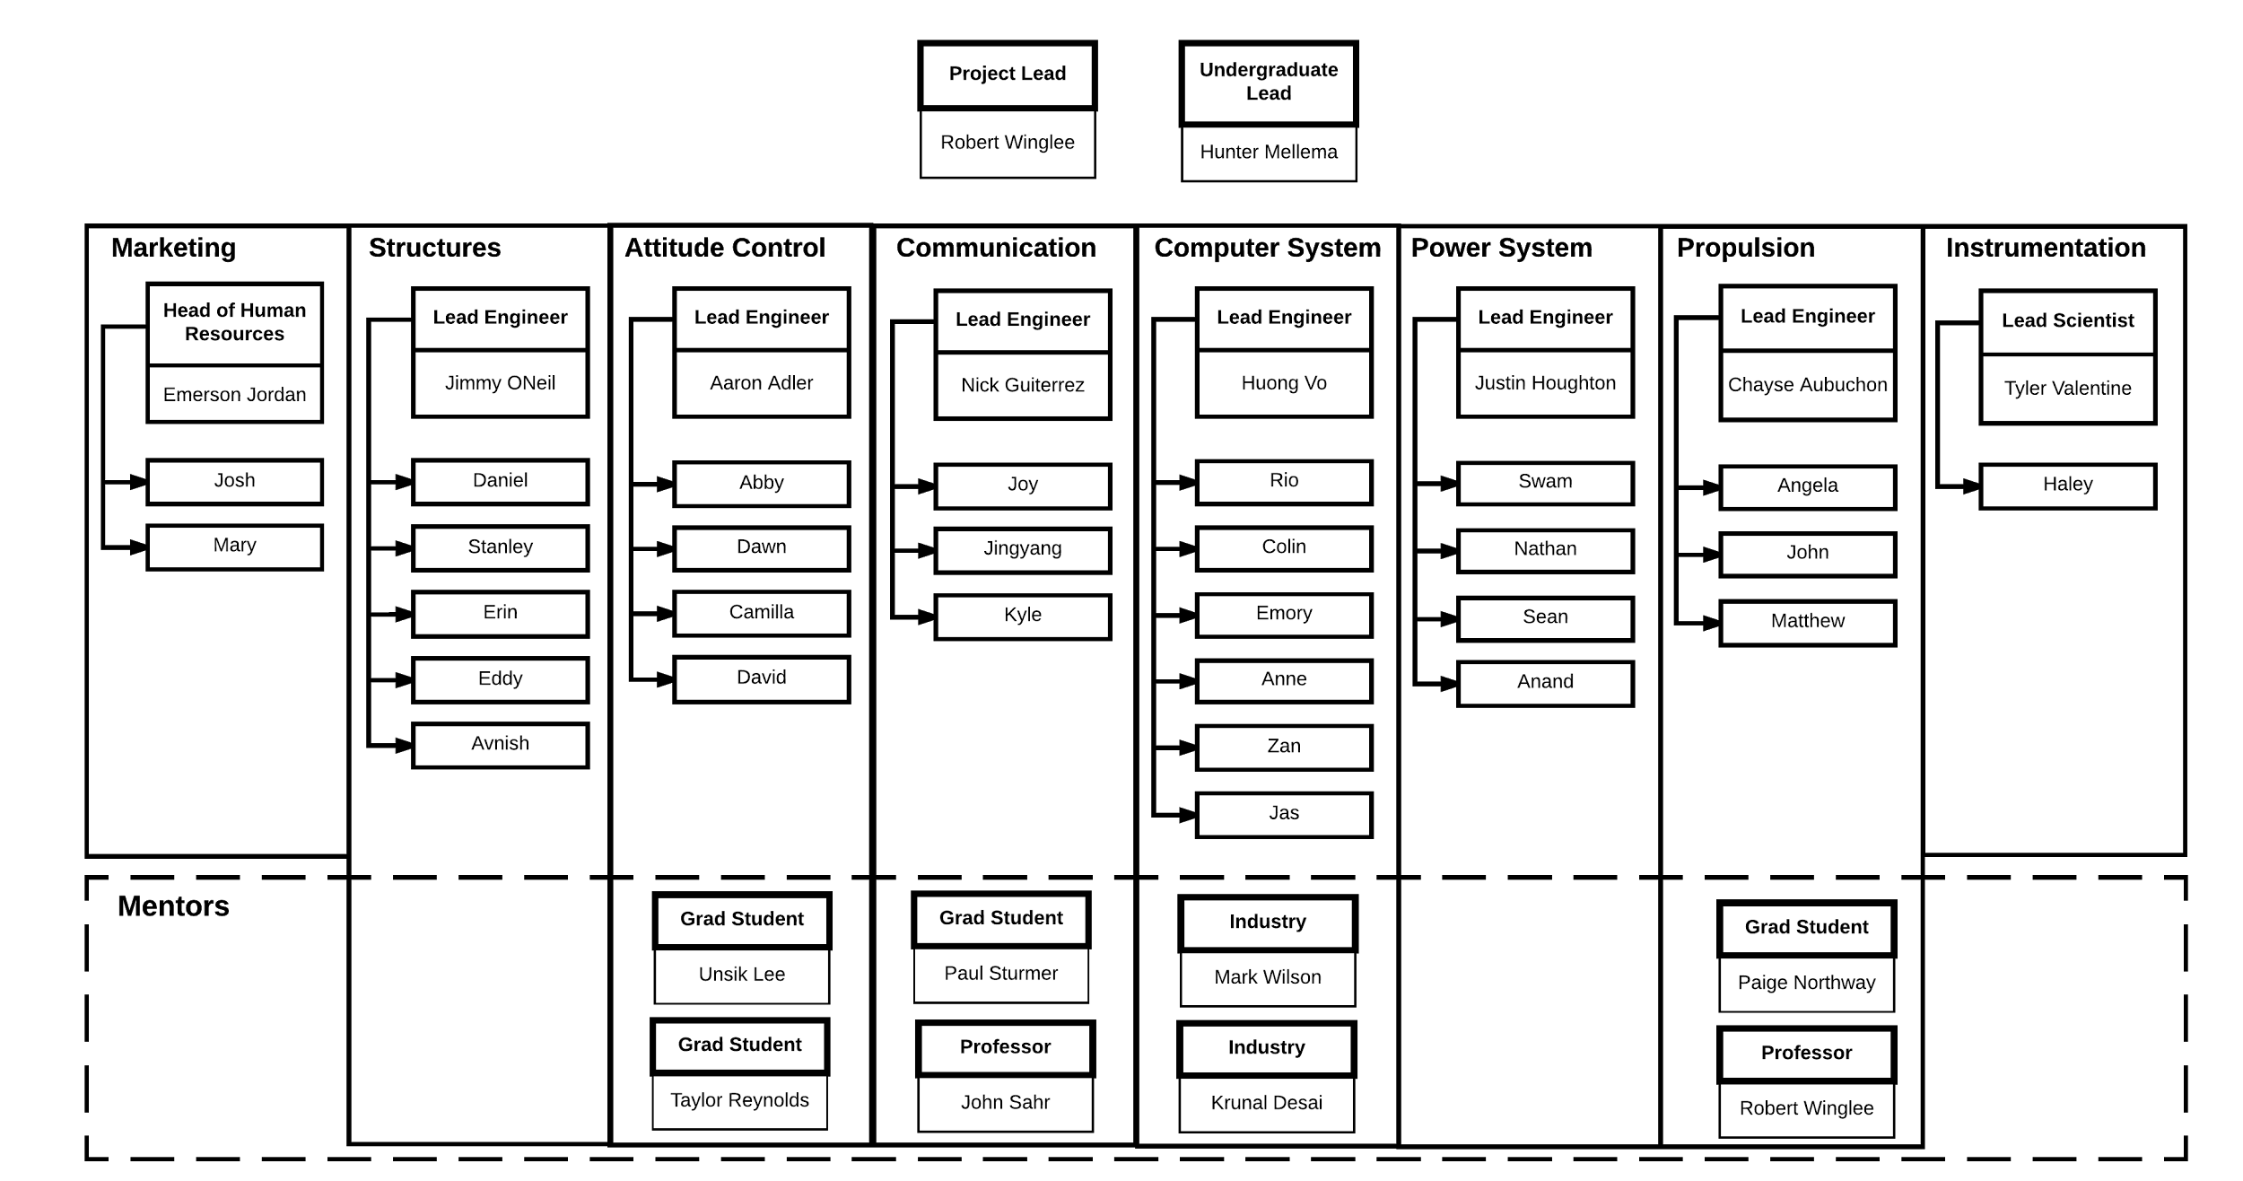

Our team consists of 37 undergraduate students, 4 graduate students and a number of academic and industry advisors. The team is broken up into 8 subsystem teams. The leaders of each of these subsystem teams are responsible for some of the systems engineering for their subsystems, but also help to manage the delegation of work on their subsystems. The overall undergraduate lead is primarily responsible for system integration and project management.

## PRIMARY MISSION REQUIREMENTS (SLIDE 3)

* Delivery of system by March 2018
* 3 months of operation
* Operational Pulsed Plasma Thruster (PPT) capable of orbit maintenance
* Downlink of 100kb using high frequency K-band antenna

## THEORY AND CONCEPTS (SLIDES 4-6)

### Pulsed Plasma Thruster Propulsion Technology Demonstration PPT schematic - Page 1 (1).png

The propulsion system technology demonstration is a sulfur ablative pulsed plasma thruster (PPT) comprising of two main electrodes, an igniter, a fuel cell, a main discharge circuit, and an igniter circuit. The PPT, generally flown with solid Teflon (PTFE) fuel, has heritage dating back to the Russian Zond missions for attitude control and station keeping. Solid fuel PPTs have the notable advantages of being simple and robust, with high fuel storage density. These advantages are important for CubeSat use, as CubeSats are frequently flown as secondary payloads subject to strict guidelines regarding pressure vessels and energy storage. The Advance Propulsion Laboratory at UW has been developing a PPT which utilizes these advantages, but is more suited to a primary propulsion source for CubeSats through optimization of specific thrust, or thrust output over power input. To date, important design features include:

1. A breech-fed coaxial design, which has the advantage of insulating the high voltage at the center of the design and can easily be scaled for larger fuel mass mission.
2. A second design feature comprises the sulfur fuel cell, which has been chosen over the typical PTFE fuel due to its demonstrated doubling the specific thrust, or thrust output per power input, over the PTFE fuel. In our power and time limited regime, a trade-off to gain specific thrust at the detriment of mass efficiency is beneficial.
3. A new design feature is the serrated, or daisy, cathode shape. The electric field at the pointed areas is increased, which experimentally increases the consistency of the main discharge breakdown across the surface of the fuel. The daisy configuration also shows close to a 2x increase in specific thrust over smooth cathode configurations of similar dimensions.

Change in velocity of the CubeSat, PPT lifetime and success rate, and sulfur propellant deposition will be studied. The applications of this low power, compact system range from orbit maintenance or raising to dispersing satellite fleets, possibly even into larger ΔV missions enabling longer term low altitude orbits or farther ranging CubeSats.

## CONCEPT OF OPERATIONS (SLIDE 8)

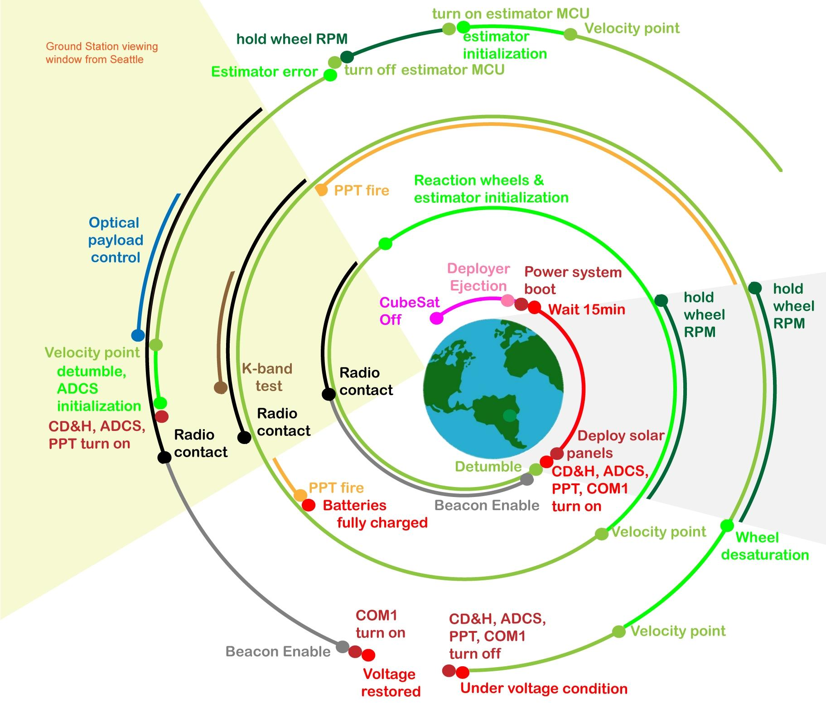

## SYSTEM LEVEL BLOCK DIAGRAM (SLIDE 9)

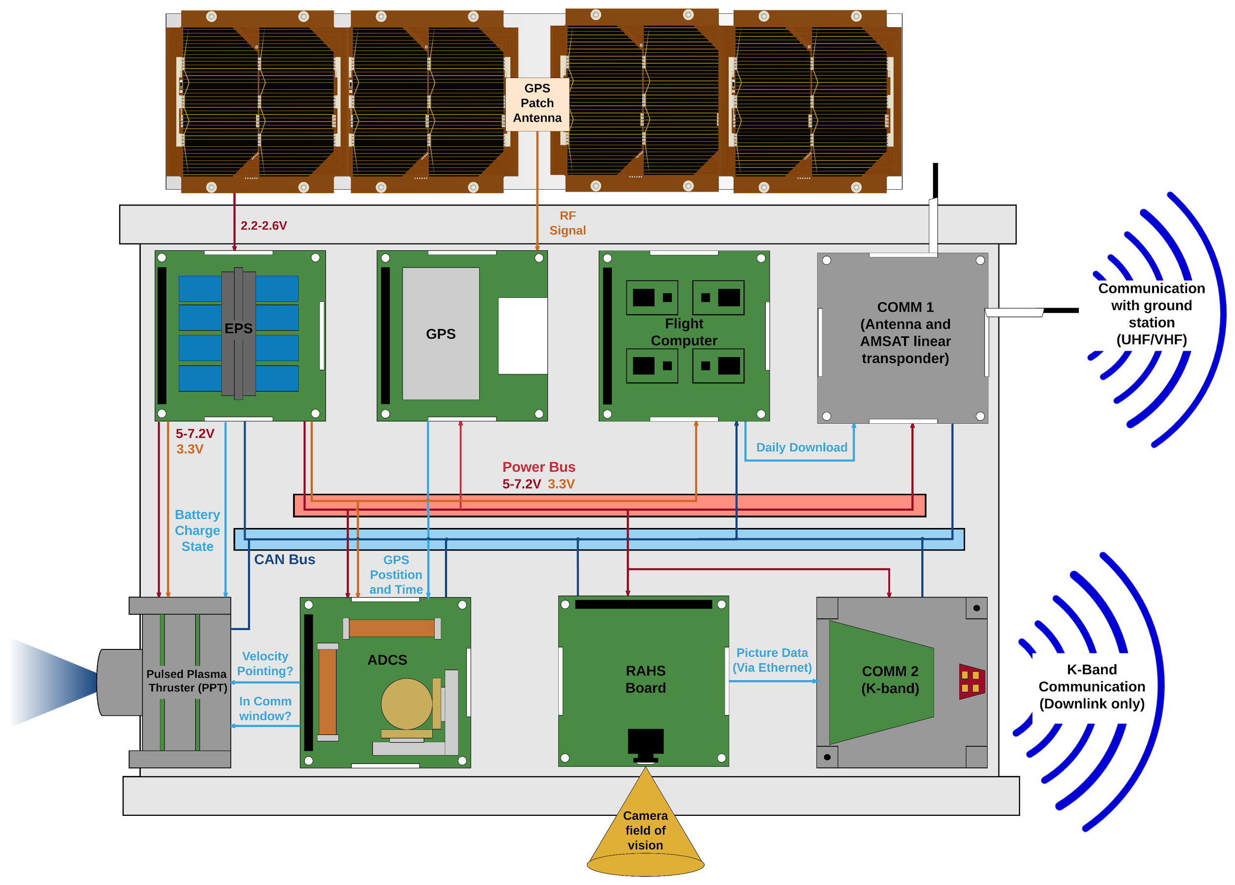

The diagram above shows how the subsystems on the satellite interface with one another. The Satellite is broken up into the following subsystems:

* Attitude Determination and Control (ADCS) [includes GPS system]
* Electrical Power System (EPS) [includes solar panels]
* Pulsed Plasma Thruster (PPT)
* K-band Communication System (COMM 2)
* UHF/VHF Communication System (COMM 1)
* Flight computer
* Raisbeck Aviation High School optical board (RAHS Board)

One key feature of HUSKYSAT-1 is that all of the subsystems communicate utilizing a decentralized CAN bus. This makes the system modular and resistant to faults in any one system.

The dark blue lines show connections on the CAN bus that transmit telemetry data. All of the telemetry data on the satellite is processed and compressed by the flight computer. When the COMM 1 system ready to transmit the daily download, the flight computer pushes the compressed data to COMM 1 for downlink. It is also possible to directly sniff the CAN bus from the ground for troubleshooting and push packets onto the bus from COMM 1.

The light blue lines in the diagram are direct communication between subsystems through the CAN bus. The PPT will wait to fire until it receives a packet from the ADCS system that HUSKYSAT-1 is not within the communication window and is velocity pointing (more information provided in the PPT section). The PPT will also monitor packets from the EPS to ensure that the battery has sufficient charge to permit firing.

The COMM 2 system and RAHS Board are tied to the same power switch which is only turned on for 10 minutes at a time. This prevents these systems from draining excess power in the event of a failure. The image data collected by the RAHS board is sent directly to the COMM 2 system via ethernet.

The ADCS, GPS, and the Flight Computer all receive both 3.3 and Vbat from the main power bus (provided by the EPS). Vbat is the battery voltage which varies between 5V and 7.2V. The RAHS Board, COMM 1, and COMM 2 all receive only a Vbat line from the main bus. The PPT system gets regulate 3.3 and Vbat lines separate from the rest of the satellite bus.

## SYSTEM CAD MODEL (SLIDES 10-11)

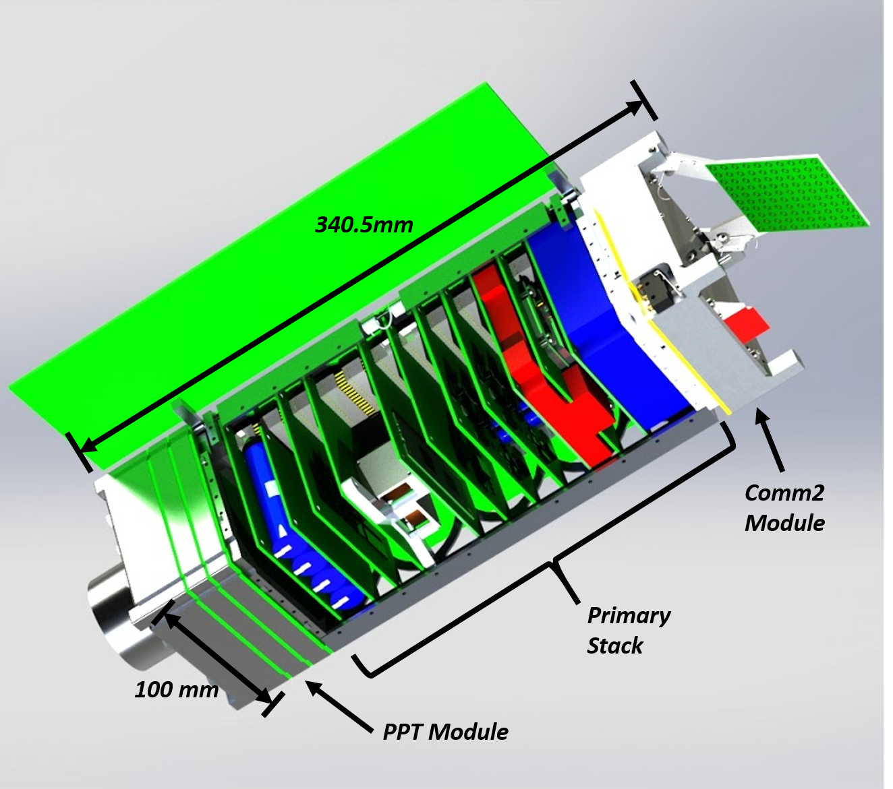

The HUSKYSAT-1 chassis consists of a primary body with two external modules, as shown above. The external modules are single point grounded to the rest of the chassis in order to prevent the propagation of electromagnetic noise from the pulse plasma thruster to the rest of the system or from the rest of the circuits to the sensitive high-frequency electronic in the Comm2 module. The primary stack of circuit boards within the main body is utilizes standard PC104 stack heights and connectors. The buildable dimensions for circuit boards taking up both one and two standard PC104 stack heights are provided below.

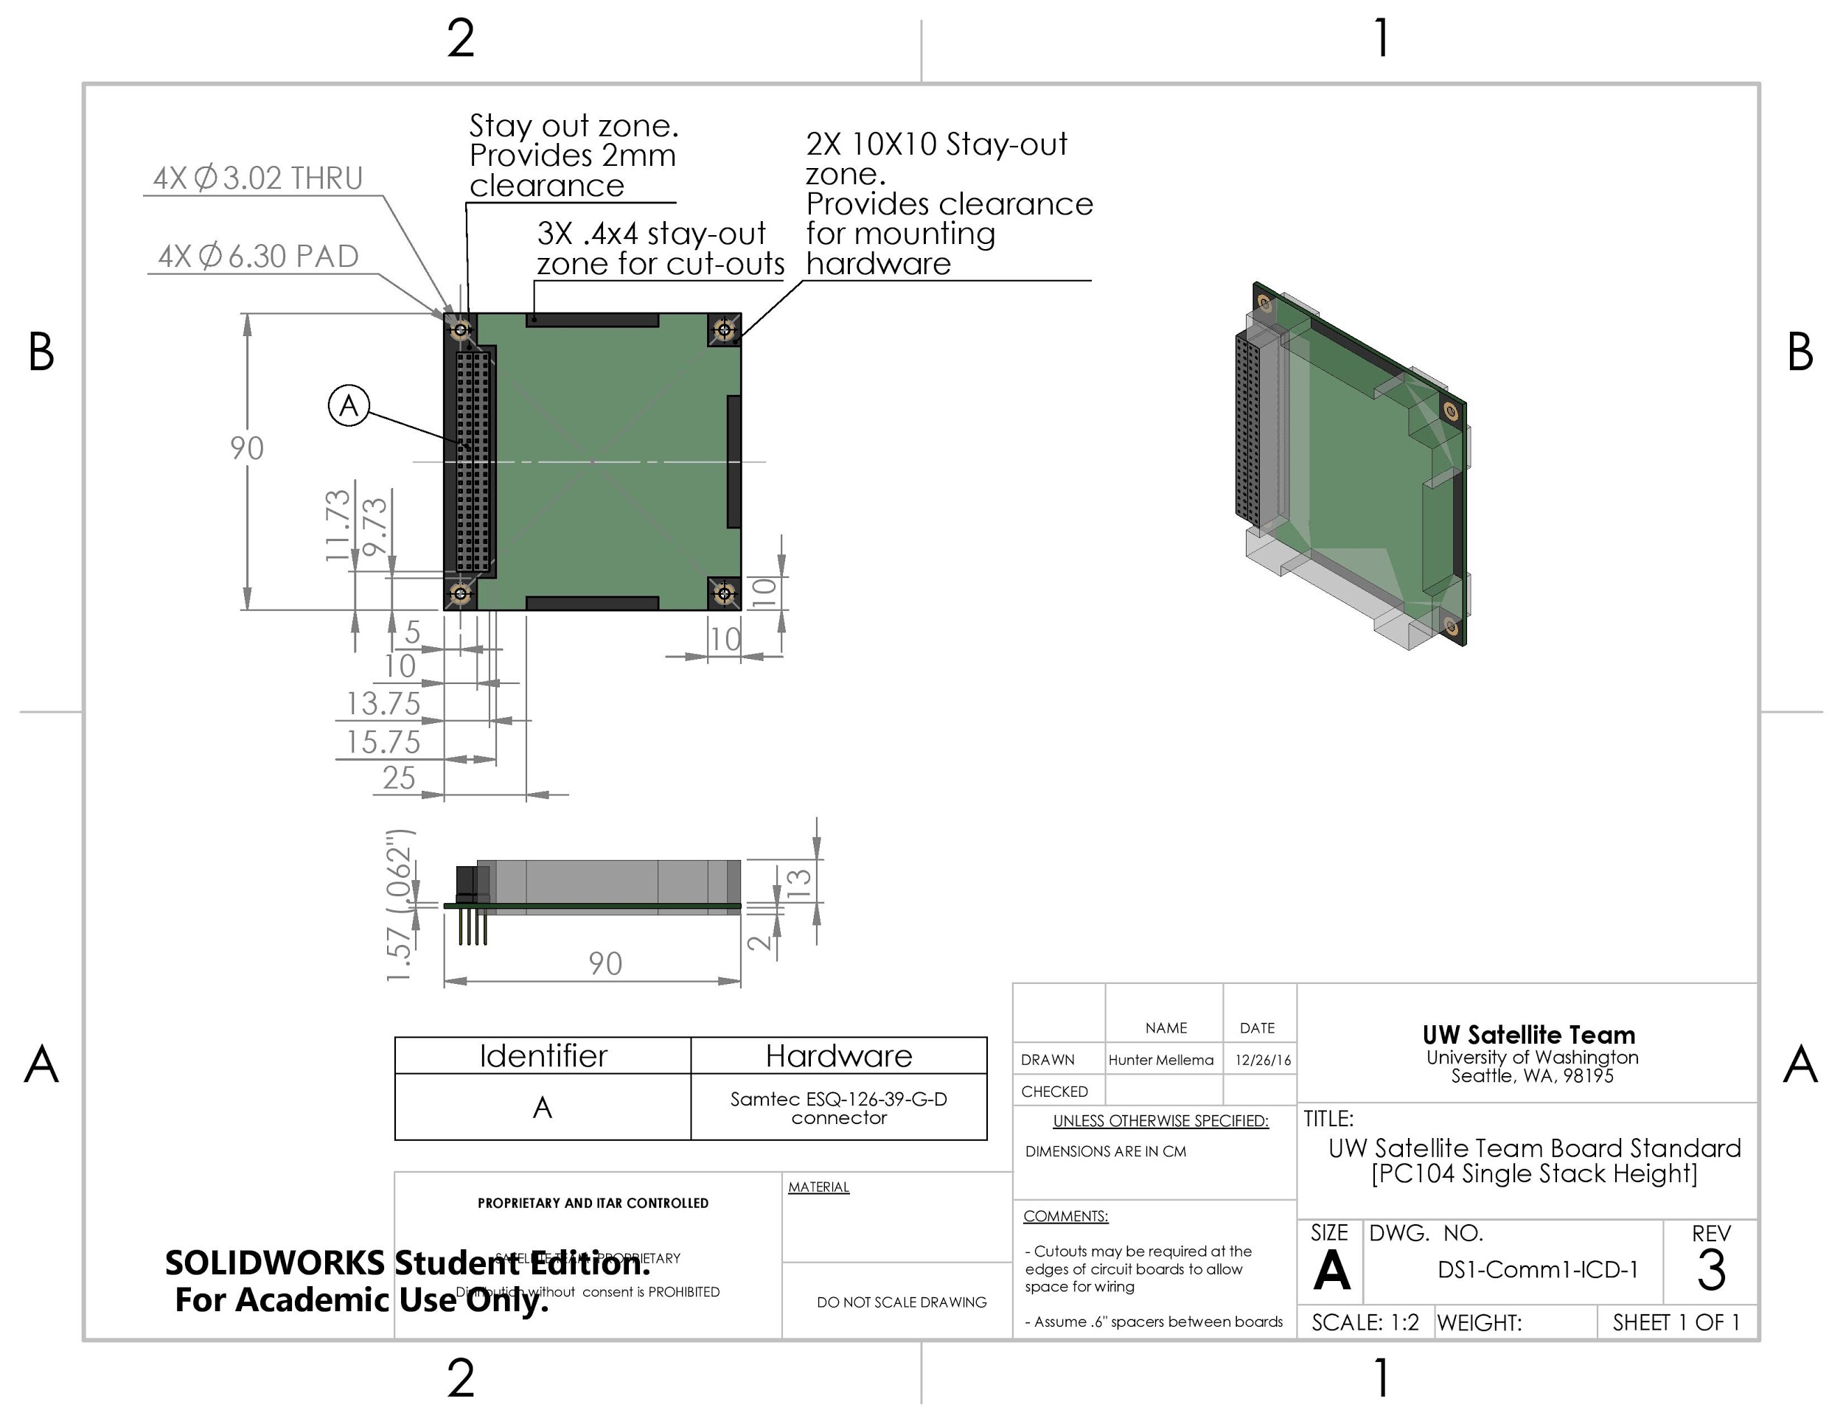

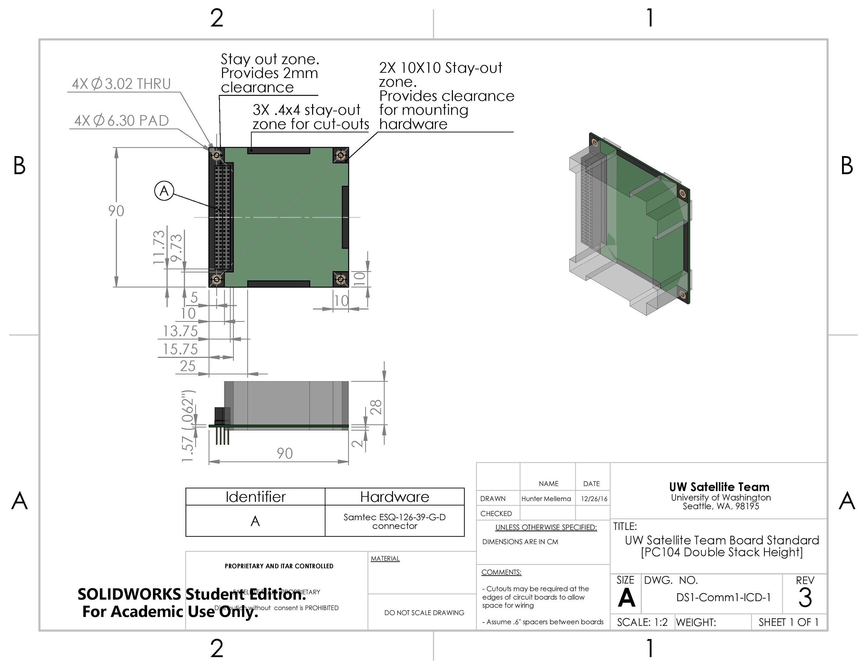

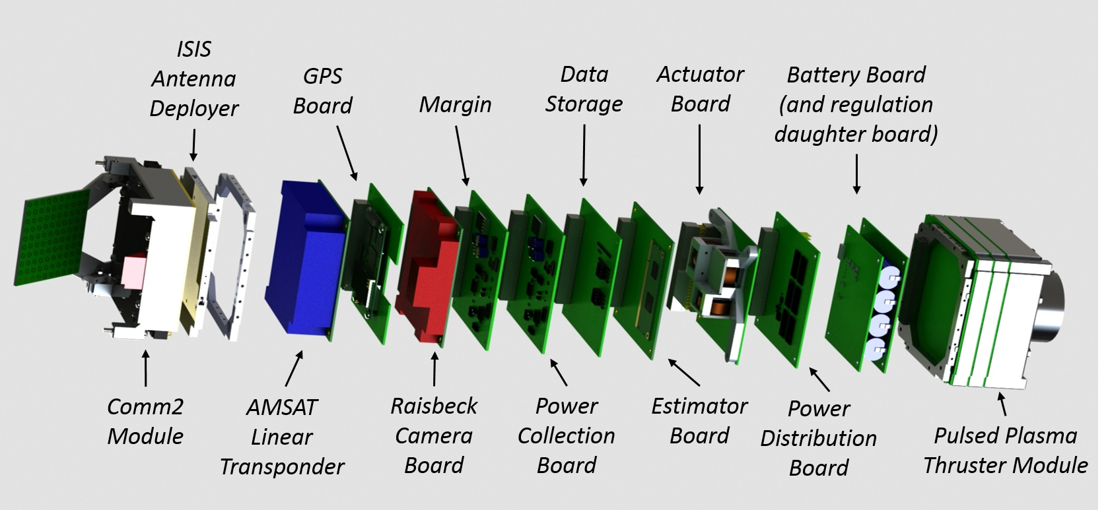

The full volume budget of the satellite is shown above. Particular features to note are the battery pack which takes up 2 standard stack heights and has a daughter board which handles the regulation of the battery circuitry. Additionally, the power system has two other circuit boards, one for power distribution, which provides the regulated rail voltages to other subsystems, and another board for collecting and conditioning power from the solar panels. The AMSAT Linear transponder has been allocated 2 stack heights and the Raisbeck aviation High School board has been allocated 1 standard stack height with a provision to allow a small cutout in the GPS board which sits just above it and a small cutout in the satellite frame to allow the camera on the board to see outside the satellite body. One standard board height has been allocated as margin.

## MASS BUDGET (Supplemental)

|  |  |
| --- | --- |
| ***System*** | ***Mass (g)*** |
| *Propulsion Module* | *600* |
| *Comm 2 system* | *600* |
| *Solar Panels* | *250* |
| *Power Module* | *350* |
| *Chassis (+solar panel hinges)* | *500* |
| *GPS board* | *150* |
| *Antenna Deployer* | *100* |
| *ADCS Module* | *650* |
| *Flight Computer* | *150* |
| *High school board* | *150* |
| *Comm 1 (AMSAT Module)* | *300* |
| *Margin* | *200* |
| ***Total*** | *4000* |

# Propulsion Subsystem (slides 16-21)

## Scope

“This system will take power input from the main satellite, and in the correct conditions will provide pulsed thrust for the spacecraft. The system will also provide health information to the main computer.”

## Critical Requirements and Interfaces

|  |  |  |
| --- | --- | --- |
| **Requirements** | **Description** | **Verification method** |
| Maintain Orbit for 3 Months | Expected average drag of 0.023 mN | Thrust stand measurements and measurements in orbit. |
| System Integrity under vibration | PPT must survive the launch environment | FEA modeling with physical shake table testing to NASA standards |
| Thermal/Vacuum | Components must survive extreme temperatures and meet NASA outgassing requirement | Outgas testing and thermal cycling of components |
| Lifetime/contamination | Must maintain thrust levels for entire mission | Lifetime testing up to 200,000 cycles at mission power levels |
| Limited Electromagnetic interference | PPT will need proper shielding to 70 dBµV/m/MHz at 1m | testing with spectrum analyzer and EMI antenna at center frequency |

|  |  |  |
| --- | --- | --- |
| **Interface** | **Description** | **Solution** |
| POW/PROP  (Power Source) | High voltage required igniter circuit and main circuit | Main and Ignitor charge boards will draw power through direct input from batteries |
| POW/PROP  (Grounding Scheme) | Need to avoid ground loops when using high voltage | Electrically isolated system with single ground point to main satellite |
| POW/ADCS/PROP  (Data Interface) | System will read data from POW & ADCS to determine when to fire | Communication ran through global CAN bus utilizing PC104 connector |
| STRUC/PROP  (Mechanical Connection) | Isolated system needs mechanical connection to main structure | 8 electrically isolated ~3 mm rods connects PPT to main chassis |
| STRUC/PROP  (Thermal Connection) | Dispersion of heat generated from thruster | Thermally isolated system, dispersed through radiation using specific surface treatments |

## System Block Diagram and Operations

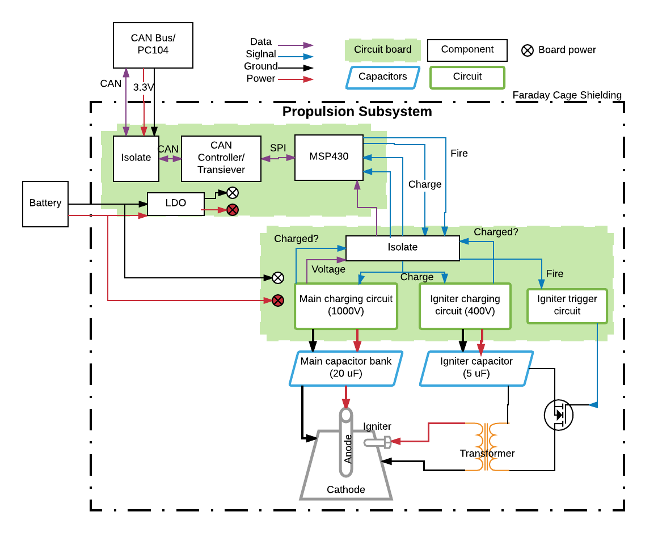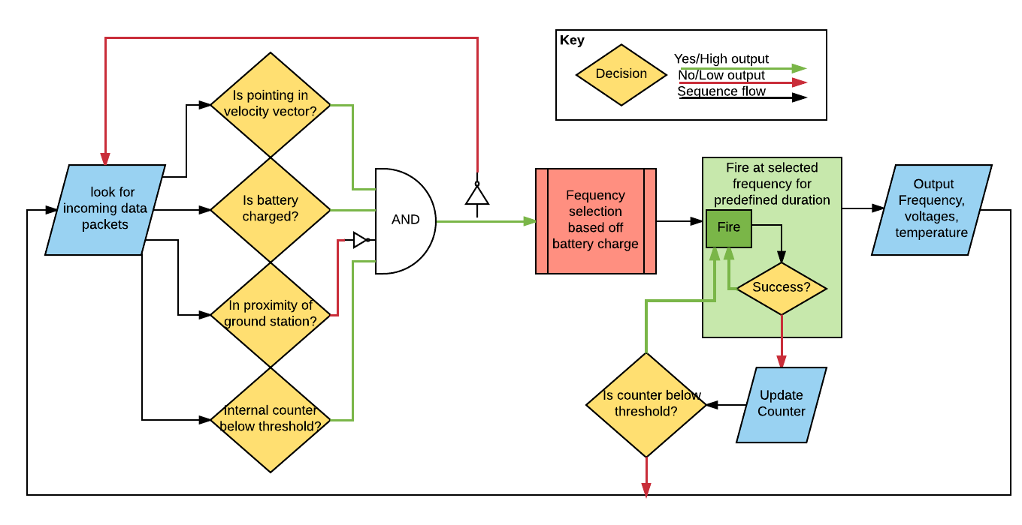

Upon receiving power, the system will immediately default to waiting for a data packet. When a data packet is received, the information on battery power, pointing, and location in the data packet will determine if the PPT fires. In the event that the spacecraft is pointing in the velocity vector, the batteries are above a threshold voltage (tentatively 6.1V) and the satellite is not in the proximity of the ground station, the propulsion system is cleared to fire.

If the satellite is not pointing in the velocity vector, thrust will be counterproductive. The battery being below a threshold is indicative of power being required for other subsystems or an eclipse state. In the event that the ground station is in range, power (and lack of EMI) is needed for operations like, Comm2 communication, use of the RAHS payload, or a data dump through Comm1. If any of these conditions are true, the propulsion system will return to waiting for a data packet that indicates it can proceed.

## CAD ModelsFrontViewPPT.jpg

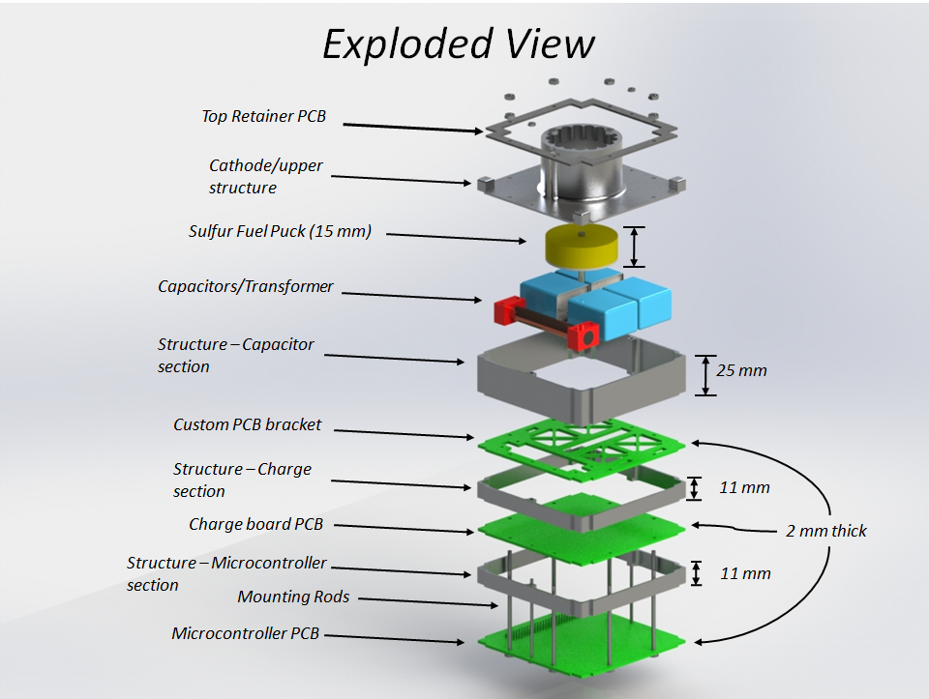

## Trade Studies

### Propellant type

|  |  |  |  |  |  |  |  |  |  |
| --- | --- | --- | --- | --- | --- | --- | --- | --- | --- |
| **Propellant** | Gallium | Teflon | Bismuth | Epoxy | Lead | Olivine | Chalcopyrite | Bi2S3 | Sulfur |
| **Specific Thrust (mN/kW)** | **7.9** | **8.5** | **9.0** | **9.7** | **9.8** | **10.5** | **11.0** | **13.6** | **19.0** |

The propellant numbers given are for the 20J discharge of a 1” pulsed plasma thruster configuration prior to other optimizations. (Hence, they are lower than other stated specific thrust numbers). Results from this study showed that most any substance that remains solid at room temperature under vacuum could be used as fuel, but that pure Sulfur, and those compounds that contained Sulfur components, provide the highest specific thrust. An approximate factor of 2 gain for Sulfur over Teflon is seen across energies from 5 to 60J. This is due to the low vaporization and ionization energies of Sulfur allowing for a larger mass bit and higher ionization fraction.

### Capacitors

The capacitors were labeled as a considerable risk after those used in short term lab testing were observed to lose capacitance over thousands of discharges. The capacitor trade study looks at a variety of thin film capacitors with a focus on energy density and a required voltage de-rating. The dV/dt of the capacitors was a major consideration, but it was infeasible to have sufficient energy density as well as a dV/dt rating up to the 200V/us peak expected value. To mitigate risks involved with going outside the specifications of the capacitors, the chosen capacitors were then tested to over 1 million pulses at the required energy. Each had a less than 2% loss in capacitance.

|  |  |  |  |  |  |  |
| --- | --- | --- | --- | --- | --- | --- |
| **Company** | **Capacitance (uF)** | **Voltage Rating (V)** | **dV/dt**  **(V/us)** | **Volume (mm^3)** | **Energy Density (J/mm^3)** | **Temp**  **Range (C)** |
| **EPCOS TDK** | **5** | **1300** | **100** | **25,294** | **@1000V, 9.88E-05** | **-55 to 105** |
| **Cornell Dubilier** | **4.7** | **1500** | **72** | **51,639** | **@1000V,**  **4.55E-05** | **-55 to 105** |
| **Vishay** | **5** | **1250** | **221** | **101,500** | **@1000V,**  **2.46E-05** | **-55 to 105** |
| **Illinois Capacitors** | **0.22** | **2000** | **2600** | **44,030** | **@1500V, 0.56E-05** | **-55 to 105** |
| **Kemet** | **1** | **2000** | **400** | **56,025** | **@1500V,**  **1.75E-05** | **-55 to 105** |
| **Cornell Dubilier** | **1** | **2000** | **754** | **71,258** | **@1500V,**  **1.58E-05** | **-55 to 105** |

## Risk Analysis

|  |  |  |  |  |  |  |
| --- | --- | --- | --- | --- | --- | --- |
| **Primary Identifier** | **Code Identifier** | **Failure Mode** | **Definition** | **C** | **L** | **Mitigation Proposal** |
| Propellant degradation | PROP | Depletion of fuel | Loss of propellant due to space environment due to high temperature and low vacuum pressure | 3 | 5 | Significant fuel margin added (2x expected) |
| Chemical Deposition | DEP | Damage to the electrodes or solar array | Deposition of fuel onto spacecraft surfaces | 3 | 4 | Continued material testing to verify severity of sulfur-material interaction |
| Fatigue | FAT | High Duty Cycle | Capacitor fatigue or electrode erosion from over 500,000 | 5 | 3 | Tungsten components and fatigue testing to validate capacitors |
| EMI | EMI | On-board computer system | Plasma interactions, electromagnetic interference causing full computer restart | 3 | 3 | Faraday cage incorporated into PPT structure design |
| High Voltage | HV | Charging board failure | High voltage system requires robust circuitry design to avoid failure | 5 | 4 | Components derated for operational parameters, physical testing to verify |

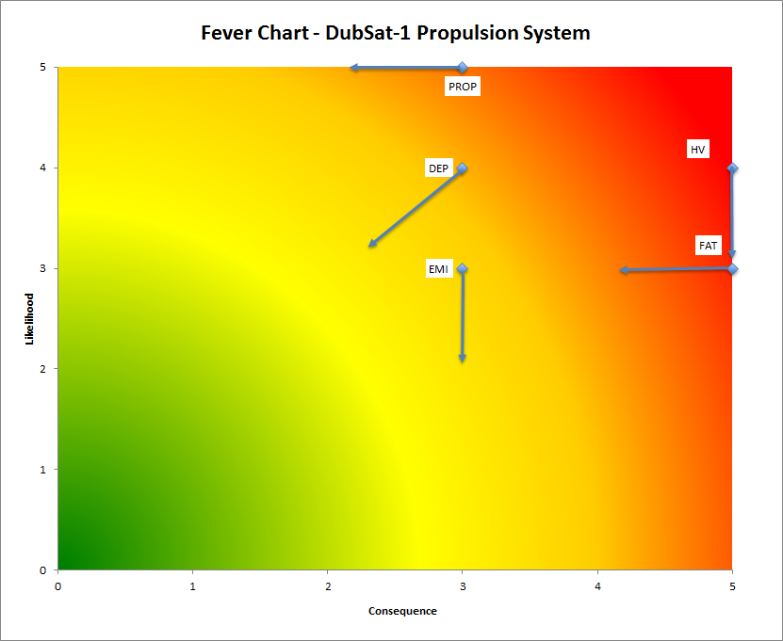

Vectors show anticipated results of stated mitigation strategies.

## Expected Drag

Using an STK simulation, the magnitude of the drag was estimated and averaged over 90 days at an altitude of 400 km, and assuming 70 degree inclination. This assumption was made to give us a general idea of drag as we assume our orbit will be near, or above 70 degree inclination resulting in less drag. An average drag of 0.023 mN is expected.   
  
Our thruster has demonstrated thrust/power of ~30 mN/kW in the 10J range. This results in an expected Impulse of 0.3 mN-s. At 5 watts of input power, and 10 Joules of energy per shot, the thrust will produce 0.15 mN at 0.5 Hz firing frequency, resulting in a thrust/drag ratio of 6.5. A minimum of ~1 watt is needed to overcome drag using the expected impulse.

## Thrust Calculation

In this section we demonstrate the calculation of performance characteristics and requirements for the PPT. Constants and standards used throughout this analysis with ~10J discharge. The ablation rate was determined by measuring mass loss over a few thousand pulses at 20J.

Gravity *g = 9.81 m/s^2*

Voltage *V = 1000 Volts*

Capacitance *C = 20 uF*

Ablation rate (measured) *abr = 3.5 ug/J*

Impulse bit (measured) Ibit = 400 µN*s

Energy: *E = 0.5 C V^2 = 10 J*

Mass bit: *mbit = abr*E = 35 ug*

Specific Impulse: *Isp =Ibit/(mbit*g) ≅ 1200 s*

Thrust Efficiency: *N = Ibit^2/(2*mbit*E) ≅ 25%*

Fuel requirements:

The fuel requirements are based of the desired change in velocity, *dv*, the starting mass of the CubeSat, *M*, and the specific impulse, *Isp*.

From the rocket equation: *m_fuel = M*(1-e^(-{dv}/{Isp*g}))*

starting with and initial mass of 4 kg, 34 grams of fuel is needed to achieve a theoretical *dv* of 100 m/s. A safety factor of 2 to more than account for drag, general inefficiencies, and pointing precision supplies 68 grams of fuel.

## Chemical Analysis of Cathode Metals

Lifetime testing of the PPT using a range of aluminum and steel alloy cathodes showed remarkably varied firing success rates. In addition, residues and crystalline coatings were moderately to heavily deposited on the electrodes and chamber walls during the test firings. Chemical analysis of the sulfur fuel, thruster materials, and deposition was used to characterize the effect of these metal alloys with sulfur fuel. The results from Fourier-Transform Infrared Spectroscopy and X-Ray Photoelectron Spectroscopy confirmed the composition of deposited materials contained a high atomic weight percentage of carbon, identified from unintentional outgassing from the polyethylene terephthalate (PETG) printed test stand. The presence of sulfides and metal oxides are believed to be partially responsible for electrode degradation trends in stainless steel and aluminum 6061 alloys. General performance of the aluminum 7075 cathode was better than the previous two alloys, but direct correlation as to whether or not the material interaction with sulfur was responsible for the increase requires further investigation. The characterization of PPT materials, specifically the cathode metals, continues to assist in contamination mitigation and can develop a means of material optimization from direct compositional analysis, contributing to mission viability of this propulsion system.

## Charging Electronics

Charging can be thought of as working in three stages after the charge signal is received by the LT3750 Charge Controller:

1. Primary side charging
   1. Once the gate signal is sent to the NMOS, Vtrans-Vds(on) appears across the primary winding
   2. Current through the primary winding rises linearly to Ipk
   3. Because our charge transformer is 1:10, the input voltage appears across the secondary windings as -10*(Vtrans-Vds(on))
   4. Negative voltage reverse biases the output diodes and stores energy in the transformer
2. Secondary side charging
   1. Once we reach the current limit (on the primary side), which is set by resistor values on the board (Rsense to be exact), the NMOS switch turns off
   2. Energy stored in the transformer now forward biases the diode and charges the output cap
   3. Output voltage is now reflected across the primary windings and sensed by the controller chip
      1. If target output voltage is reached, DONE pin goes low and chip stops operation
      2. If not reached, we move into stage three
3. Discontinuous Mode Detection (DCM)
   1. Output voltage divided by 10 is reflected across the primary winding
   2. Transformer with no DC voltage can’t support the DC voltage reflected across the primary winding, so the voltage decays to zero
   3. Once voltage rings down to Vtrans, the whole procedure repeats until the target output voltage is reached

### Schematic and PCB Layout Decisions

*Version 1:*

The original flyback charger schematic, as well as further iterations, was largely modeled after the one given in the LT3750 Charge Controller datasheet.

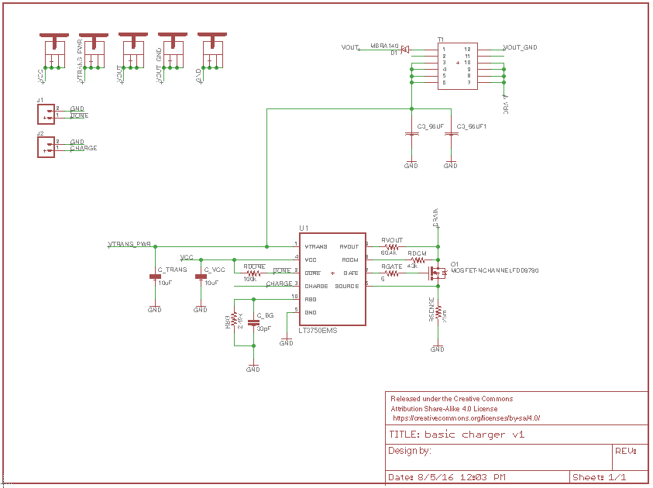

The charger’s three input power lines are VTRANS, VCC, and GND. As VTRANS and VCC will be derived from the same battery source, they have been wired together at 6.6 volts in further iterations. Despite the low voltage, these lines will be pulling a large amount of current through them and require large PCB traces to help dissipate heat.

Three resistors on this schematic are of particular importance: rvout, rbg, and rsense. The manipulation of rvout and rbg set the target output voltage, i.e. when the charge controller should stop, according to this equation: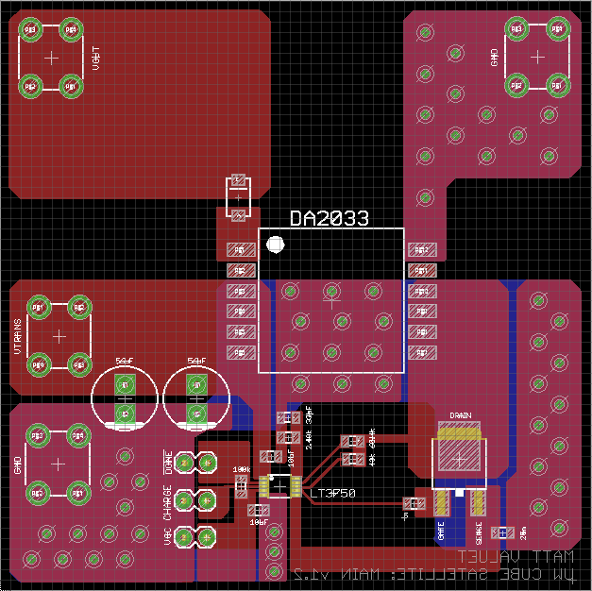

vout = (1.24 volts * N * \frac{rvout}{rbg}) - vdiode

For the v1 board, the values of rvout and rbg are set to 60.4k ohms and 2.49k ohms, respectively; this resulted in an output voltage lower than our current iterations. Rsense determines the current limit through the primary winding of the charge transformer, set by Amps = 78mV/rsense. The version 1 rsense value was set to approximately 25m ohms.

The final iteration of the version 1 PCB, shown above in EAGLE CADsoft, was 72.5 mm x 72.5 mm two layer board. A smaller transformer was used, the Coilcraft DA2033-AL, because of the lower current and power specifications.

It should be noted that the board was laid out specifically so that there would be no large current loops on the primary side. As current passes through the primary side of the transformer and out the source of the NMOS, it is pushed down into the ground plane and back around on itself. A large current loop could push out a great deal of electromagnetic interference (EMI), causing issues with both the charge controller and nearby electronics on the satellite.

Additionally, the rvout, rdcm, and gate signals are all isolated from both the ground layer and from copper pours around them because they have been shown to be extremely noisy lines.

*Version 2:*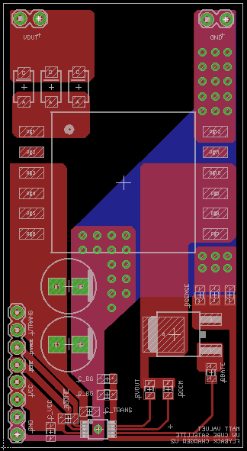

Few changes were made to the v2 schematic, but the change log is as follows:

* Screw terminals were abandoned in favor of a standard 8-pin header for input and two standard 2-pin headers for output
* Footprints for two more output diodes were added
* Footprints for two more 0805 rsense resistors were added
* Coilcraft DA2034-AL transformer replaced the DA2033-AL

The version 2 board layout is 35 mm x 65 mm, less than half the size of v1. Large power traces are still present in the design, however they are designed to fit just within the calculated trace width requirements for the amount of current passing through them. Current looping has been minimized where possible, but there is still one large loop showing in the bottom left corner where it passes from vtrans, through the bypass capacitors, and down towards the ground pins. No appreciable effect has been seen.

As for component values, this board was designed for 1kV output and the resistor values to achieve that were:

* Rvout = 100k ohms
* Rbg = 1.3k ohms
* Rsense = 8m ohms OR 12m ohms

All other component values, other than those above in the description and in the bullet points, have stayed the same.

### Charge Board Testing

All versions have gone through (1) efficiency testing and (2) thermal analysis, while only v2 has undergone additional (3) fatigue testing.

1. Efficiency testing
   1. At every 100 volt increment, an average frequency and duty cycle measured. This average on time for the primary coil is used to determine the amount of energy being used on the primary side, or the input energy. (½)CV^2 is used to determine the output energy. With these two, we can determine the efficiency of the circuit.
2. Thermal analysis
   1. Both the NMOS and the transformer are prone to high heat output, so a temperature sensor is used to take measurements for long, repeated charge intervals.
3. Fatigue testing
   1. An Arduino is used to automatically charge and fire a PPT lab system for an extremely large number of shots.

# Electrical Power System (Slides 22-26)

## System Scope

The power system converts solar energy to electrical power. This power maintains the charge on the satellite batteries. Power is drawn from the batteries to provide specific voltage rails for individual subsystems.

## EPS Critical Requirements

Table 4: Critical Requirements

|  |  |  |
| --- | --- | --- |
| **Requirement** | **Description** | **Verification Method** |
| Pavg = 5 W | Required power through entire orbit. Margin of error included in solution. | Orbit simulation based on Pmax, Test panels |
| Kill Switch Operation | Satellite must not have power until switch is disengaged. | Test at multiple stages in satellite build |
| Batt T > -30 C | Low battery temp while charging can cause battery lifetime issues. | Vary temp in prototype, observe circuit reaction |
| Batt T < 60 C | High battery temp is unstable. | Vary temp in prototype, observe circuit reaction |
| ~6.6 V and 3.3 V Rails | Unregulated battery voltage and regulated 3.3 V for logic devices. | Inspect using meter during prototype and FlatSat |

## EPS Critical Interfaces

Table 5: Critical Interfaces

|  |  |  |
| --- | --- | --- |
| **Interface** | **Description** | **Solution** |
| Solar Panel → EPS | Flexible connection, vibration resistant, rated for > 4 A. | Trade study to determine optimum solution. |
| Kill Switch → EPS | Satellite power OFF until kill switch is disengaged. | Mechanical switch isolating batteries and panels. |
| EPS Telemetry → Comm1 | Comm1 transmits satellite status. | CAN Bus. Well tested data bus, suitable for harsh environments. |
| Power → Comm1 | If power to Comm1 fails, there will be no communication with the satellite. | Redundant power supply and only disable power to Comm1 in low Vbatt situations. |
| Power → EPS MCU | MCU within EPS is critical to power switching for all subsystems. | Redundant power supplies that are powered directly from MPPT. |

## 

## EPS Power Flow

Figure 1 displays the flow of power from, through, and to critical components. Power starts at generation – three solar panels containing a total of 20 AzurSpace 3G30A solar cells (7 + 6 + 7) for a max power of 24 W at 136 mW/cm2. Each panel is connected to 6 SPV1040 max power point trackers (2 in series, 3 parallel pairs). The output of the MPPTs all go to one point, the first internal kill switch. The kill switch prevents power flow from the solar panels until the switch is disengaged. There is one external switch, two internal. After the solar panel kill switch, a small amount of power flows directly to a linear regulator (LDO) that provides power for the EPS micro-controller (MCU) and the solar panel output current sensors (not shown).

One power connection exists between the power gen board and the battery board, VBATT, ranging from 5-7 V for battery charging. On the battery board, there are two switches controlling the charge and discharge of the batteries. Control of the switch preceding the batteries prevents overcharge and charge during low temperature. The switch prior to the batteries prevents under charge, high temperature discharge, and overcurrent protection. In between these two switches is a line with a diode to allow power from batteries to power the MCU LDO during eclipse or scenarios when the first switch is open. There exists another LDO on this board to power the battery control and balancing devices. Also located between these two switches is a line to the battery heater. When the battery approaches low temp conditions, the heater can be switched on to prevent having to open the charging switch. The battery control and balancing controls power flow to and from the batteries. The batteries are isolated from the rest of the circuit by the second internal kill switch. The batteries are four APR18650m1A with two in series and two in parallel. This configuration allows us to provide a battery voltage around 6.6 V and max discharge of 60 A. While they are limited to 60 A, this is not a desired current flow and will be controlled by many safety devices in critical locations.

One power connection exists between the battery board and the power distribution board of VBATT, ranging from 5-7 V. Power from this line is sent directly to individual subsystems, as needed, but can be switched off when necessary. The 5-7 V also powers multiple current sensors (not shown). Two buck converters in parallel (redundancy) are used to provide 3.3 V for individual subsystems. These lines can be controlled by switches and are also monitored by current sensors.

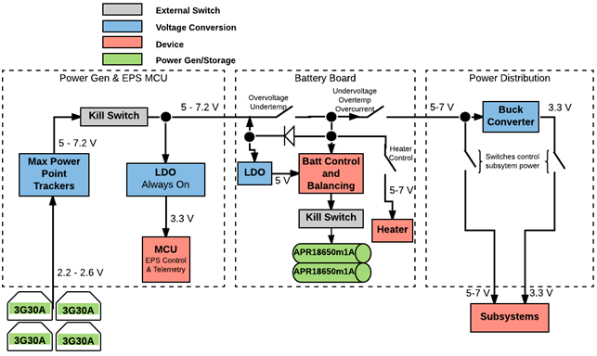

Figure 1: EPS Power Flow Diagram

## Signal Flow

Figure 2 displays signals containing telemetry or signals used to control specific devices. The center of the signal flow within EPS is the MSP430FR MCU. The battery balancer, coulomb counter, and current sensors all send telemetry to the MCU via I2C protocol. Battery telemetry is used in making some decisions on-board about power management and forwarded to COMM1 for transmission to ground. Power telemetry is not used in any on-board decision making, but only sent to COMM1 for transmission to ground. EPS telemetry is sent from the MCU to COMM1 using the CAN bus. GPIO pins from the MCU control power flow to the subsystems and switching of the battery heater. There is a voltage divider which provide a reference voltage from the battery to the MCU.

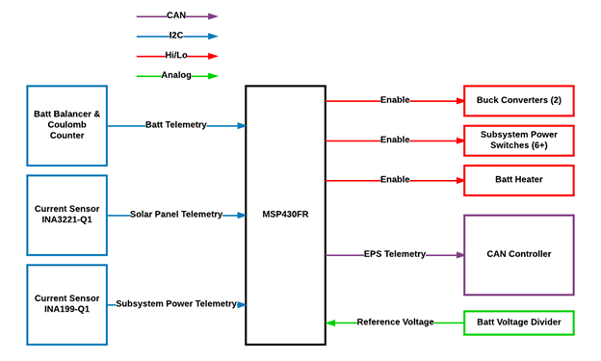

Figure 2: EPS Signal Flow Diagram

## Solar Cell Trade Study

We compared solar cells from two different manufacturers, SpectroLab and AzurSpace. TrilSolX is listed under a different company, but the wafer comes from AzurSpace. After collecting enough data, we decided on the AzurSpace 3G30A solar cells. Within the table, red denotes an area where the solar cell either did not meet requirements or is drastically inferior. Green is interpreted as either greatly exceeding requirements or are significantly superior. Most numbers in the following spreadsheet are either directly from the spec sheet provided by the company, or derived from those values.

Table 1: Solar Cell Comparison

|  |  |  |  |  |  |  |  |
| --- | --- | --- | --- | --- | --- | --- | --- |
| **Brand** | SpectroLab | SpectroLab | SpectroLab | **AzurSpace** | AzurSpace | AzurSpace | TriSolX |
| **Model** | UTJ Leone | UTJ 2 Per | XTJ Leone | **3G30A** | 3G28C | 3G30C | 3G28C |
| **Flux** | 135 mW/cm2 | 135 mW/cm2 | 135 mW/cm2 | **136 mW/cm2** | 136 mW/cm2 | 136 mW/cm2 | 135 mW/cm2 |
| **Area/cell** | 53.3 cm2 | 26.62 cm2 | 59.65 cm2 | **30.18 cm2** | 30.18 cm2 | 30.18 cm2 | 1.3 cm2 |
| **Dimensions** | 70 x 79 mm | 40 x 80 mm | 80 x 80 mm | **40.15 x 80.15 mm** | 40 x 80 mm | 40 x 80 mm | 10 x 26.3 mm |
| **Thickness** | 340 um | 340 um | 340 um | **280 +/- 25 um** | 150 +/- 20 um | 150 +/- 20 um | 160 um |
| **Mass** | 6.5 g | 3.3 g | 7 g | **3.561 g** | 2.595 g | 2.595 g | 0.175 g |
| **Diode** | Bypass | Bypass | Bypass | **Bypass** | Bypass | Bypass | No |
| **Coverglass** | Yes | Yes | Yes | **Yes** | No | No | No |
| **Prod Time** | 2 weeks | 6-8 weeks | 2 weeks | **8-12 weeks** | 8-12 weeks | 8-12 weeks | Ready |
| **V**mp | 2.3 V | 2.35 V | 2.35 V | **2.409 V** | 2.371 V | 2.411 V | 2.33 V |
| **I**mp/cell (mA) | 869 | 434 | 1015 | **502** | 487 | 504 | 19 |
| **I**mp/cm2 (mA) | 16.30 | 16.30 | 17.02 | **16.63** | 16.13 | 16.7 | 14.6 |
| **W/cell** | 2 | 0.998 | 2.385 | **1.209** | 1.154 | 1.215 | 0.044 |
| **$/cell (qty)** | $400 (55) | $265 (~40) | $450 (~30) | **$252 (40)** | $202 (40) | $206/cell (40) | $8/cell |
| **$/W** | $200 | $265 | $188 | **$208** | $175 | $170 | $182 |
| **W/cm**2 | 37.52 | 37.50 | 39.99 | **40.07** | 38.26 | 40.26 | 33.8 |
| **W/g** | 0.3077 | 0.3024 | 0.3407 | **0.3396** | 0.4449 | 0.4682 | 0.2514 |
| **Array Config** | 4 x 4 x 4 | 8 x 8 x 8 | 4 x 4 x 4 | **8 x 8 x 8** | 8 x 8 x 8 | 8 x 8 x 8 | 113 x 120 x 113 |
| **Max Output** | 24 W | 23.95 W | 28.6 W | **29 W** | 27.7 W | 29.1 W | 15 W |
| **Total Cells** | 12 cells | 24 cells | 12 cells | **24 cells** | 24 cells | 24 cells | 346 cells |
| **Array Cost** | $4,800 | $6,360 | $5,400 | **$6,048** | $4,848 | $4,944 | $2,768 |
| **Total Cost** | $22,000 | $10,600 | $13,500 | **$10335 + VAT** | $8335 + VAT | $8495 + VAT | $4,500 |
| **Array Mass** | 78 g | 79.2 g | 84 g | **85.5 g** | 62.3 g | 62.3 g | 60.55 g |

Interpreting the table:

Brand: Company manufacturing the cells.

SpectroLab, American division of Boeing.

AzurSpace, German.

Model: Solar cell version which correlates with the data.

Flux: Solar Flux standard used to compute the data.

Area/cell: Surface area of an individual cell for this model.

Dimensions: X & Y, used for modelling the potential array layout and size. SpectroLab

UTJ Leone did not provide dimensions. I assumed the size based upon the area given and the existence of a different UTJ cell at 39.5 x 70 mm.

Thickness: Spectrolab provided bare cell and coverglass thickness separately, they

are “working” to provide me with exact numbers.

Mass: Combined mass of the cell and the coverglass. SpectroLab has not yet

provided mass, but I found data in spec sheet for bare cell mass at 84

mg/cm2, then added mass for the glass based upon azurspace glass mass/cm2.

Diode: Is there a diode? What configuration?

Coverglass: All cells have an Anti-Reflective coating. Does the cell come with

coverglass? This has not previously been an absolute requirement, but it has recently been strongly suggested that it should be a requirement.

Prod Time: Time the company estimates it will take to produce the solar cells. This

does not include shipping time.

Vmp: Voltage of a single cell at max power.

Imp/cell: Current of a single cell at max power.

Imp/cm2: Current per cm2 at max power.

W/cell: Watts produced by a single cell at max power.

$/cell (qty): Cost of an individual cell (based upon a purchase of X solar cells)

Numbers chosen to meet CubeSat requirements and the test setup on a weather balloon.

$/W: Cost per Watt for a single cell.

W/cm2: Watts per cm2 at max power.

W/g: Watts per gram of solar cell (coverglass mass included) at max power.

Array Config: For the 3U CubeSat. Assuming three surfaces, each with an area of 8 x

32 cm. L x C x R is the number of cells on each panel based upon the

given cell dimensions.

Max Output: Max power output of the array with the configuration described above.

Total Cells: Total cells used in an array for the CubeSat.

Array Cost: Cost of only the cells used in the CubeSat array.

Total Cost: Total cost of solar cells based upon the quantity listed above in the “$/cell

(qty)” section. The AzurSpace cells also require a VAT (import/export tax).

Array Mass: Total mass of only the solar cells used in the CubeSat array. Not including

PCB mass.

## Battery Trade Study

The battery trade study looked at the composition of different types of batteries – NiCd, MiMH, Lead Acid, LiFePO4, Li-Po, and Li-Ion. Most of the battery types were eliminated due to instability within the required temp ranges, excessive mass required to meet DubSat-1 demands, or inability to meet cycle requirements. In the end, we decided on LiFePO4 18650 batteries.

Table 2: Battery Comparison

|  |  |  |  |  |  |  |
| --- | --- | --- | --- | --- | --- | --- |
| Battery Chemistry | NiCd | NiMH | Lead acid | **LiFePO4** | Li-po | Li-ion |
| Cell voltage (nominal) | 1.2 | 1.2 |  | **3.3** | 3.7 | 3.7 |
| Mass (g) | 411 | 247 |  | **39** | 80 | 94 |
| Discharge temp (C) | 20 to 60 | -20 to 65 |  | **-30 to 60** |  | -20 to 60 |
| Charge temp (C) | 0 to 45 | 0 to 45 |  | **-30 to 60** |  | 0 to 45 |

Challenges of implementation

NiCd: Requires periodic complete discharge, charge complete state difficult to detect

NiMH: Charge complete state even more difficult to detect than NiCd

Lead acid: Cannot meet cycle requirements

**LiFePO4: Battery balancing required**

Li-po: Vacuum stability, battery balancing, sensitive to overcharge, less flight heritage than LiFePO4 or

Li-ion, appropriate data for 1500 cycle achievement difficult to find

Li-ion: Battery balancing, more difficult to detect state of charge than LiFePO4

## EPS Risks

Table 3: Risk Table

|  |  |  |  |  |  |  |
| --- | --- | --- | --- | --- | --- | --- |
| **Primary Identitifier** | **Code Identifier** | **Failure Mode** | **Definition** | **Conse-quence** | **Likeli-hood** | **Mitigation Proposal** |
| Overheat | HOT | Internal electronics, external radiation | Heat - sun & internal electonics Failure to control the temp causes changes in battery life, voltage levels, and capacity | 3 | 4 | Temperature monitoring integrated with switches to disable charge/discharge until back within required limits. No active temp management plan. |
| Noise | NOISE | Sun, Space, Radios | Space and CubeSat electronics will introduce noise to the power lines. | 3 | 3 | Low Pass Filters |
| Vibration | SBS | Launch vehicle, PPT impulse | Vibration from launch and thruster could shake loose solar cells or electrical connections on PCBs | 2 | 4 | Vibration testing & Kapton tape with the solar cells |
| Fail to Meet Power Req | 2LTL | < 5 W Pgen-avg | A plethora of issues could cause DubSat-1 to generate less power than needed. | 3 | 1 | Margin of error to mitigate risk: Pgen-avg = 7.7 W, |
| Solar Cell Damage | HOBA | Debris | Damage to a single cell pulls down the performance of all other cells (in series, decreased V; in parallel, decreased I) | 2 | 2 | Coverglass |

Figure 4: Fever Chart

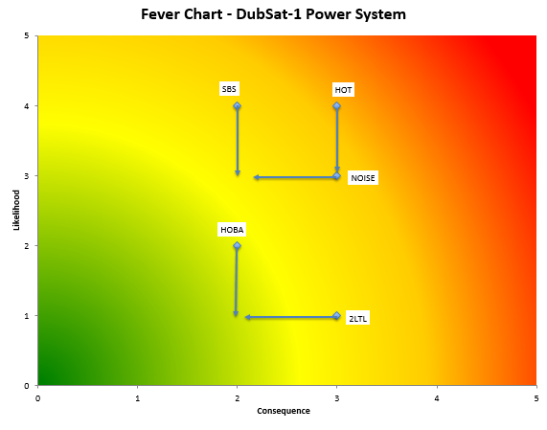

# ATTITUDE CONTROL SYSTEM (Slides 27-31)

The ADCS, or Attitude Determination and Control System, will determine the position and attitude of the satellite and will point the satellite as required by the mission. In satisfying these requirements, the ADCS must avoid generating unwanted disturbance torques and must absorb the effects of environmental torques. The ADCS will exert torque on DS-1 via a combination of a 3-axis magnetorquer array and a 3-axis reaction wheel system. Attitude will be determined with an array of kinematics and environmental sensors, particularly an array of photodiodes on the exterior of DS-1, a sun sensor, and a magnetometer. The ADCS will act autonomously to maintain a velocity pointing attitude, and it will relay its current pointing information and any diagnostic and telemetry information to the rest of the satellite via the CAN bus.

## Critical Requirements

The critical system requirements are summarized in the table below:

|  |  |  |
| --- | --- | --- |
| Requirement | Verification Method | Description |
| Attitude Control over Mission Lifetime | Analysis, Test | Provide attitude control about all 3 of the satellite’s principal axes for 3 months. |
| Velocity Pointing | Analysis, Test | Hold a velocity pointing attitude with the reaction wheels for 60% of the orbit. |
| Torque Compensation | Analysis, Test | Compensate for disturbance torques, expected to be 7×10-6 Nm. |
| Stability Maintaining | Analysis, Test | Avoid negatively impacting the stability of CubeSat, inducing disturbance torques less than 10-7 Nm. |
| Attitude Determination | Analysis, Test | Provide accurate attitude information to the main computer system. |

* Attitude control over mission lifetime: The ADCS will provide attitude control for the entire duration of the mission. That means that the reaction wheels, the magnetorquers, and all ICs must function for 3 months, the expected mission lifetime.
  + This is to be verified by analysis of the parts involved to ensure that they are of suitable durability to survive a LEO environment, and by testing parts such as the magnetorquers and the reaction wheels rigorously before launch.
* Velocity pointing: The ADCS must accurately point the satellite along the velocity vector, requiring it exert an instantaneous 0.012 mNm torque.
  + This will be verified by analysis, ensuring that mathematical models predict that the satellite will be able to exert this much torque, and by testing, particularly using an air bearing and a helmholtz coil, to ensure the cubesat is able to exert this much torque.
* Torque compensation: The ADCS must be able to compensate for disturbance torques created by the PPT, solar pressure, drag, and other outside forces.
  + The testing will be identical to that of velocity pointing, and the analysis will be supported with other mathematical models.
* Stability maintaining: The ADCS must not create disturbance torques on the cubesat. This means it must be able to fully control both the magnetorquers and the reaction wheels, and that they must be properly controlled by the ADCS.
  + This will be extensively modeled, and the disturbance torques will be pinpointed and eliminated. We will also test the ADCS on the air bearing and the helmholtz coil to test the level of disturbance torque which it may create.
* Attitude Determination: The ADCS must at all times be able to relay pointing information to the other subsystems. This information will come from an array of sensors including GPS, magnetometers and photodiodes.
  + We will test this using unit testing on the central estimator, as well as using the helmholtz coil and the sun simulator. Additionally, we will use a unit testing suite and environment simulation.

## Interfaces

The critical interfaces are summarized by the table below:

|  |  |  |
| --- | --- | --- |
| Interface | Description | Solution |
| COMM2/ADCS | ADCS will need to hold velocity pointing attitude while COMM2 transfers data. | CAN bus: ADCS will send pointing information across the CAN bus, to be received by COMM2.  EMF: ADCS will notify COMM2 of any magnetorquer control to avoid electromagnetic interference. |
| Power/ADCS | Power will need to know current attitude and deliver power to ADCS. | CAN bus: ADCS will send pointing information across the CAN bus, to be received by Power.  Power bus: ADCS will receive power from the global power bus |
| C&DH/ADCS | C&DH will receive pointing information and distribute it to the other subsystems on the satellite. | CAN bus: ADCS will send diagnostic, telemetry, and pointing information across the CAN bus, to be received by C&DH. |
| PPT/ADCS | The PPT system will request pointing information to ensure velocity pointing thrust. ADCS will also need to compensate for disturbance torques generated by the PPT. | CAN bus: ADCS will send diagnostic, telemetry, and pointing information across the CAN bus, to be received by PPT.  EMF: ADCS will notify COMM2 of any magnetorquer control to avoid electromagnetic interference. |

* Interface with COM-2: ADCS will need to provide pointing information to COM-2. Without this, COM-2 will not know when to begin transmission. ADCS will need to tell COM-2 when the antenna is within 3 degrees of the ground station.
* Interface with Power: ADCS will need to receive reliable power from the power subsystem. ADCS will also need to tell Power the current attitude for diagnostic and solar cell pointing information.
* Interface with C&DH: ADCS will need to tell C&DH all pointing and diagnostics information available for communication.
* Interface with PPT: The ADCS will need to issue pointing information to the PPT to ensure that it is only thrusting parallel to the velocity. This information will be transmitted over the CAN bus. ADCS will also need to compensate for all of the disturbance torques generated by the PPT, expected to be on the order of 4.7×10-6 Nm of torque.

## Risks

The primary risks considered were the following:

* Central Estimator Latching (CEL): Many things, from radiation damage to unexpected behavior, may cause the central estimator to latch. A latched central estimator may issue undesired commands and be unresponsive to interaction. This can be mitigated effectively by writing a robust watchdog system between the BDOT controller and the central estimator, and implementing a non-volatile cache system to preserve the Kalman filter state through a power failure.
* Reaction Wheel Motor Failure (RWF): The reaction wheels are highly susceptible to mechanical wear-and-tear. A failure of any one of the reaction wheels means that that axis of attitude control is lost during downlink or PPT firing, which is projected to be 60% of the orbit. We intend to mitigate the likelihood of this by installing ceramic bearings on the ends of the motor shafts to prevent vibration.
* Magnetorquer H-Bridge failure (MTHB): The H-Bridge is the most vulnerable part of the magnetorquer unit. If this part fails, that axis of magnetorquer is rendered ineffective, preventing proper desaturation. We will emphasize the choosing of radiation hardened parts and selecting an H-Bridge with proper back-EMF protection, rated to at least 30V back-EMF surges.
* Assorted IC failure (ICF): Many of the ICs used in the ADCS are susceptible to radiation damage. The primary methods of mitigating this issue are to use redundant ICs when practical, use anti-radiation coating on anything critical, and use a distributed control scheme to minimize central pipelines where failure would be more catastrophic. The existing mitigation scheme of using the decentralized BDOT controller will mitigate the damage of a central estimator failure or an MSP 430 failure on its own.
* Power failure (PF): A power failure will result in the loss of the current state of the Kalman filter approximating attitude, resulting in a complete lack of pointing information when the satellite is in earth’s shadow, and a need to re-establish attitude once the satellite is in the sun. This can be mitigated by using non-volatile storage for the central estimator. State re-establishment time is projected to be on the order of a fewminutes, meaning this will be less devastating once the satellite exits eclipse. Another concern is that the natural decay of the reaction wheels during power-off time will cause unexpected torques that need to be corrected once power is regained.

## Fever Chart

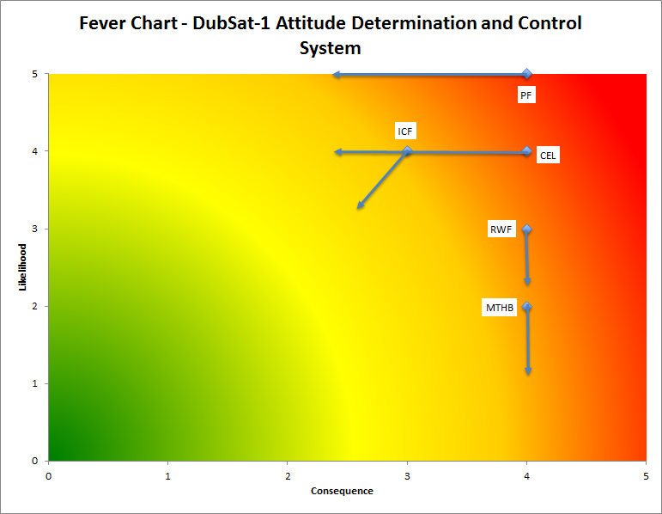

## Trade study

The two primary trade studies performed cover the reaction wheel motor and the photodiodes respectively. The results are as follows:

### Reaction Wheel Motor

|  |  |  |  |  |  |
| --- | --- | --- | --- | --- | --- |
| Model and Brand | Faulhaber 1202 004 BH | Faulhaber 1608 003 BH | Maxon EC 10 Flat | FaulHaber 2209 | Portescap 21BF |
| Maximum OD (mm) | 12 | 16 | 10 | 22 | 21 |
| max torque (mNm) | 0.16 | 0.2 | 0.24 | 0.09 | 2.7 |
| temperature range (degree C) | -30 to +85 | -30 to +85 | -40 to + 85 | -30 to +85 | -30 to +80 |
| mass (g) | 1.1 | 4.1 | 0.82 | 8.5 | 10 |
| Max Speed (rpm) | 24,000 | 20,000 | 10,000 | 19,000 | 8,000 |
| Rotor Inertia (g-cm^2) | 0.125 | 0.628 | 0.08 | 1 | 1.8 |
| Sensor type | 3 Hall Sensor | 3 Hall Sensor | 3 Hall | Capacitive | 3 Hall Sensor |
| Nominal voltage (V) | 4 | 3 | 4 | 5 | 5 |
| Necessary Flywheel Diameter | 25.6 | 26.6 | 32 | 26 | 33.6 |
| Combined Mass | 13 | 16.42 | 18 | 21 | 30 |

The Faulhaber 1202 004 BH was chosen as our motor of choice due to its ability to use a compact reaction wheel and its small mass.

### Photodiodes

|  |  |  |  |  |
| --- | --- | --- | --- | --- |
| Criteria | Weight | Options | | |
| VEMD6060X01 | BPW34FS | SFH 2430 |
| Wavelength Sensitivity Range | 2 | 7 | 4 | 10 |
| Wavelength of Peak Sensitivity | 1 | 5 | 4 | 10 |
| Half Angle | 2 | 8 | 7 | 7 |
| Spectral Sensitivity | 3 | 3 | 9 | 5 |
| Temperature Coefficient | 3 | 8 | 5 | 6 |
| Capacitance | 2 | 8 | 7 | 2 |
| Weighted Average | | 6.0 | 5.8 | 5.8 |

The SFH 2430 Z was ultimately chosen due to its increased flight heritage and available documentation.

# STRUCTURES (Slides 32-37)

## Critical Requirements

|  |  |  |  |  |  |  |  |  |  |  |  |  |
| --- | --- | --- | --- | --- | --- | --- | --- | --- | --- | --- | --- | --- |
| The Structures critical requirements are summarized in the table below:   |  |  |  | | --- | --- | --- | | Requirement | Description | Verification Method | | Structural Integrity | Maintain structural integrity under NASA GEVS loading conditions | Computational FEM Analysis, Vibration Table Dynamics Test | | Secured Deployables | All deployables must remain secured to CubeSat under NASA GEVS loading conditions | Computational FEM Analysis, Vibration Table Dynamics Test | | Thermal Plan | Disperse thermal energy if temperature gets too hot in any one area. Keep electronics maintained between (-55 - 125 deg C) | Computational Thermal Analysis, Vacuum Chamber Thermal Test |  * Structural Integrity: This requirement is inherent of the subsystem. The Structures subsystem must design and build a satellite that maintains its structural integrity throughout the entire mission lifetime. The majority of the loading conditions as well as the harshest ones will occur when the CubeSat is being launched into orbit. A list of these loading conditions can be found in the NASA GEVS as well as the user guide for the rocket that the CubeSat will be placed in.   + Verification method: To confirm the structural integrity of the CubeSat, computational finite element analyses will be conducted which simulate the loading conditions the CubeSat will experience. These computational analyses will be experimentally backed up with a physical vibration test. The vibration test will be conducted using a programmable vibration table. * Secured Deployables: This requirement states that the Structures subsystem will be responsible for not only designing the deployables but also for making sure they remain secured to the CubeSat before and after deployment. The loading conditions that these deployables experience are transferred by the main structure. Therefore, we will also use the NASA GEVS to apply loading conditions to the deployables.   + Verification method: The verification method for this requirement is the same as the verification of the structural integrity. * Thermal Plan: The final requirement of the Structures subsystem is that it must have a thermal plan in place for two reasons: 1. To avoid build-up of thermal energy and 2. To regulate the internal temperature of the CubeSat and maintain it within operating conditions of the electronics on-board. If thermal energy is concentrated at any point in the CubeSat structure, then the structure could get too hot which either causes structural damage or damage to a component of the CubeSat that results in mission failure. Finally, if the electronics in the CubeSat are not within their operating conditions, it could cause either critical damage or it could result in the electronics shutting down. The electronics on this CubeSat must be maintained within -55 to 125 deg C.   + Verification method: To demonstrate that the thermal plan works, computational thermal analyses will be used along with a physical test inside of a vacuum chamber. During both methods of testing, the CubeSat will be put through the thermal conditions that it will experience while in space. Both the simulation and the physical test will verify that the thermal plan being used is successful. |

## Interfaces

|  |  |  |  |  |  |  |  |  |  |  |  |  |
| --- | --- | --- | --- | --- | --- | --- | --- | --- | --- | --- | --- | --- |
| The Structures subsystem interfaces are given in the following table:   |  |  |  | | --- | --- | --- | | Interface Name | Description | Potential Solution | | POW/STRUC/COMM  (Mechanical Connection) | All deployables must remain secured from NASA GEVS loading conditions | Panels secured by hinges with torsional springs. Nylon burned with nichrome. ISIS deployer for antennas | | PROP/STRUC  (Mechanical Connection) | Isolated system needs connection to main structure | 8 electrically isolated ~3 mm rods connects PPT to main chassis | | POW/INSTR/CON/STRUC  (Thermal Regulation) | Electronics in CubeSat stay within operating temperatures | Active or passive thermal systems to be used |   This table is just a summary of each interface. Here is a more detailed explanation of each interface:   * POW/STRUC/COMM: This is an interface between Structures and the Power and Communications subsystems. The idea behind it is that Structures must keep the deployables needed for both of these teams secured to the CubeSat while loading conditions defined by the NASA GEVS document are being applied to the CubeSat. Further loading conditions may also be defined by the user guide of the rocket NASA decides we will launch with.   + There are solutions for securing each deployable to the CubeSat before and after deployment.   + The solar panels will remain attached to the CubeSat through the use of torsional hinges. These hinges will not only keep the solar panels attached but they will also be used to assist the solar panels in their deployment. The properties of the torsional springs to be used in the hinges is being investigated at this time and depends on the maximum amount of torque we can expect the hinges to experience during the mission lifetime.   + Both the solar panels and the reflectarray will remain in their un-deployed states through the use of nylon string. The nylon string itself will be connected to nichrome wire. When it is time for the solar panels and reflectarray to deploy, the nichrome wire will have a current run through it which heats up the nichrome wire and allows it to cut through the Nylon string.   + The communications antennas will be deployed using an ISIS antenna deployment system. This system will stay secured within the CubeSat structure and will deploy the antennas when the flight computer deems it is time. * PROP/STRUC: This is an interface between Structures and the Propulsion subsystem. The reason for the interface is inherent of the mission: The PPT provides the CubeSat thrust and therefore must be attached to the CubeSat. However, due to the modular setup of the CubeSat, the PPT is an isolated component of the structure and needs to be attached through mechanical means.   + The solution to be employed is to use 8 electrically isolated rods that will connect the PPT to the main chassis. These rods will be about 3 mm in diameter. * POW/INSTR/CON/STRUC: This is an interface between Structures and most of the subsystems that are utilizing electronics in the CubeSat. It is a requirement of the Structures subsystem to maintain these electronics within operational temperatures.   + The thermal plan that will be put into place by the Structures subsystem will either make use of passive thermal systems (those that do not require power) or active thermal systems (those that do require power) or a combination of both. If active systems are used, there will need to be communication between Structures and Instrumentation to implement a way to measure the temperature in the CubeSat at all times. |

## Risks

|  |
| --- |
| A table of the risks the Structures subsystem must alleviate as much as possible is linked on this page. A fever chart is also included to show how the risks will be mitigated by our proposals.  About each risk:   * ComIn: Vibrational loads during launch cause points of high stress throughout the CubeSat structure which eventually leads to a structural failure.   + The consequences of this risk could be catastrophic but the likelihood isn't great.   + The likelihood of this risk coming into fruition can be decreased almost completely with extensive vibrational testing and finite element analysis. * ThermPlanFail: The risk here is that thermal energy remains concentrated around the CubeSat which leads to structural damage.   + Another component of the risk is that the thermal plan put in place cannot maintain the internal temperature of the CubeSat for electrical or computer-related reasons.   + This would be catastrophic if it happened and the likelihood is believed to be reasonable at this time.   + Using conductive materials should mitigate the likelihood of structural damage occurring. Research into mitigating electronic failure is being done at this time. * SolHinFail: The torque that is acting on the hinges is greater than expected due to the vibrational loads felt by the CubeSat. This causes material failure in the hinges.   + The consequences of this happening would be great but the likelihood of this happening are small at this time.   + The likelihood can be decreased even more with extensive testing with a spring that has a stiffness determined to be sufficient for our mission. * CorroStruct: The structural integrity of the CubeSat is compromised due to corrosion from the sulfur propellant used in the PPT.   + The consequences of this happening would be great and it is very likely to happen during the mission.   + The likelihood of this happening can be mitigated by coating the structure of the CubeSat with a material  Trade Study The cutout designs that were examined are shown below.   Tested Properties **Mass:**   * + We want the chassis panel to be as light as possible   **Resonant Frequency:**   * + We do not want the panel’s natural frequency to fall within those given by the Falcon-9 document (0-100Hz)   **Max Von Mises stress:**   * + Which one will have the smallest Von Mises Stress when applied the same loading condition?   + Where is stress concentrated? |

### Parameters

* **Used NASA combined load factor and information for a worst-case scenario flight aboard the Minotaur 1 rocket to determine worst-case loading conditions**
* **Assumed a static analysis could be conducted in place of a dynamic analysis using this factor for now**
  + Understood that a dynamic analysis still needs to be conducted
* **Based on the setup of the CubeSat, assumed that the loading could be modeled as if it is being transferred through the panel’s sides**

**Method of testing**

**Mass:**

* + Used SolidWorks mass evaluation tool

**Resonant Frequency:**

* + Ran a frequency analysis in SolidWorks

**Max Von Mises Stress:**

* + Determined max loading conditions (static and dynamic loadings account for)
  + 1200 N of force applied to both sides of the CubeSat panels
  + Used SolidWorks FEA simulation to find stresses

### Results

|  |  |  |  |  |
| --- | --- | --- | --- | --- |
| Chassis Design Type | Mass (g) | Max von Mises Stress (MPa) | Stress/density (m/s)^2*10^-3 | Resonance Frequency (Hz) |
| Semi-circle | 41.5 | 60.7 | 2.16 | 256 |
| X-pattern (3-X’s) | 42.43 | 140 | 49.8 | 116 |
| X-pattern (4-X’s) | 46.2 | 81.5 | 29.0 | 132 |
| Honeycomb (5mm) | 55.52 | In progress | In progress | In progress |

Note: The resonance was the first property tested for. Due to the non-ideal frequency of the honeycomb panels, we threw these out immediately

Another note: The resonant frequency given is the first natural frequency of the structure

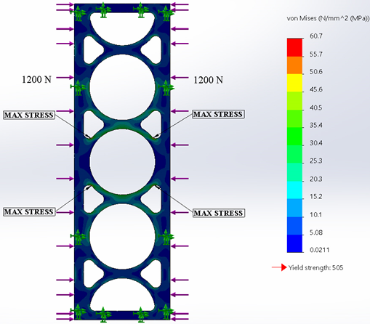

Plot of the analyzed chassis panel

**Preliminary Thermal Model**

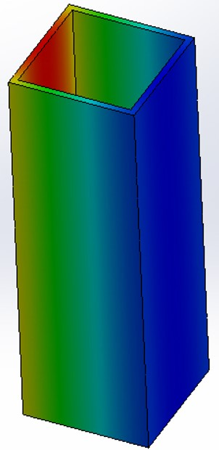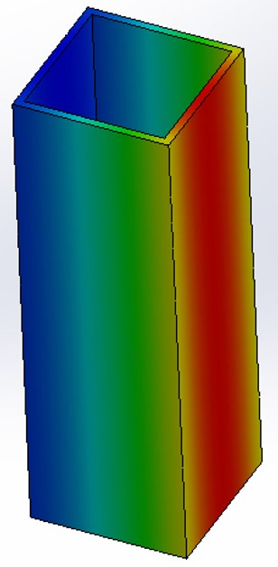

Temperature gradient for the worst case cold (left) and worst case hot (right) scenarios

**Completed work:**

The thermal model we have completed so far has determined rough estimates of the lowest and highest temperatures the CubeSat can experience during its mission lifetime. The lowest temperature the CubeSat can experience occurs during the time when the CubeSat is in eclipse. The highest temperature will be experienced when the sun is facing the CubeSat directly.

**Assumptions:**

The simplifying assumptions used for this model is that we are dealing with 1D heat transfer, the ambient temperature around the CubeSat is 2.7 Kelvin, the CubeSat temperature is in equilibrium, and the heat generated by the internal components is 7 W when the sun is up and 3 W during eclipse. Furthermore, the CubeSat was treated as a box with no ends and has a view factor with Earth of 0.15. Finally, the heat flux per square meter from the sun is 1412 W/m2.

**Analysis:**

The 1D analysis places the CubeSat between the Earth and the sun with only one side of the CubeSat facing one or the other for the hottest temperature scenario. The sun is removed for the cold temperature scenario. The following power balance on the CubeSat is used to determine its surface temperatures:

${\dot{\{Q\}}}_{in}+{\dot{\{Q\}}}_{gen}={\dot{\{Q\}}}_{out}$

In other words, the heat per time (Watts) that goes into the system plus the heat generated inside must be equal to the heat leaving the system. The power balance can be extended further. The power going into the system includes albedo or incident radiation from the earth, the earth’s radiation itself, and the sun’s radiation. The heat being generated is the power dissipated from the internal electronics. Finally, the heat leaving the system is the radiation that the CubeSat emits.

${\dot{\{Q\}}}_{albedo}+{\dot{\{Q\}}}_{E,R}+{\dot{\{Q\}}}_{sun}+{\dot{\{Q\}}}_{gen}={\dot{\{Q\}}}_{emitted}$

This 1D analysis was compared to simulations ran in SolidWorks Simulation.

# DATA HANDLING (Slides 38-41)

## SUMMARY

This document details the two possible architecture choices for the Command & Data Handling Subsystem: a centralized approach versus a decentralized approach. The centralized approach makes use of a single MSP432 microcontroller to handle all core processes and a real-time operating system to achieve multitasking. The decentralized approach makes use of 4 MSP430FR microcontrollers, each in charge of an independent, agnostic task, working together to accomplish the same processes as in the centralized approach. After discussing the advantages and disadvantages of both approaches, we will make a recommendation for a decentralized solution, making use of four MSP430FRs.

## ARCHITECTURE OVERVIEW

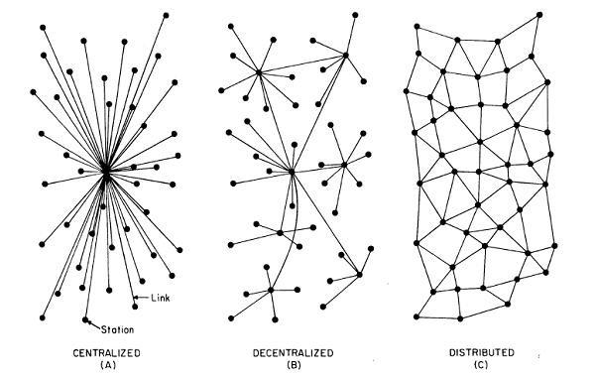

Figure 1: Overview of the three types of architectures [https://medium.com/ @bbc4468/centralized-vs-decentralized-vs-distributed-41d92d463868#.q90y9h6ud]

As seen in the diagram above, a centralized architecture uses one central computer to do all or most of the processing/computing. Thereafter, the central CPU is also responsible for delivering all logic, processing, and resources to the attached subsystems. Alternatively, a decentralized system differs in that there is no single point where the decision is made, distributing control to many parts of the architecture. However, note that no single node in the system will ever have complete system information in a decentralized network. Finally, a distributed system also uses a sharing of control across the architecture, but differs in that each node will have complete system information. In our discussion, we are not going to consider a distributed network.

## MICROCONTROLLER OVERVIEW

The two microcontrollers that we are considering for the design are the MSP432P401R and the MSP430FR5739.

MSP432: http://www.ti.com/product/msp432p401r

1. Core

(a) ARM 32-Bit Cortex-M4F CPU With Floating-Point Unit and Memory Protection Unit up to 48-MHz Clock

(b) Wide Supply Voltage Range (1.62 to 3.7 V)

(c) -40◦C to 85◦C Operation

2. Ultra-Low-Power Operating Modes

(a) Active: 80 μA/MHz

(b) Low-Frequency Active: 83 μA at 128 kHz (Typical)

(c) LPM3 (With RTC): 660 nA (Typical)

(d) LPM3.5 (With RTC): 630 nA (Typical)

(e) LPM4: 500 nA (Typical)

(f) LPM4.5: 25 nA (Typical)

3. Memories

(a) Up to 256KB of Flash Main Memory (Organized Into Two Banks Enabling Simultaneous Read/Execute During Erase)

(b) 16KB of Flash Information Memory (Used for BSL, TLV, and Flash Mailbox)

(c) Up to 64KB of SRAM (Including 6KB of Backup Memory)

(d) 32KB of ROM With MSP432 Peripheral Driver Libraries

Specifications: http://www.ti.com/lit/ds/symlink/msp432p401r.pdf

MSP430FR: http://www.ti.com/product/msp430fr5739-ep

1. Core

(a) 16-Bit RISC Architecture up to 24-MHz Clock

(b) Wide Supply Voltage Range (2 to 3.6 V)

(c) -55◦C to 85◦C Operation

2. Optimized Ultra-Low-Power Modes

(a) Active Mode: 81.4 μA/MHz (Typical)

(b) Standby (LPM3 With VLO): 6.3 μA (Typical)

(c) Real-Time Clock (LPM3.5 With Crystal): 1.5 μA (Typical)

(d) Shutdown (LPM4.5): 0.32 μA (Typical)

3. Ultra-Low-Power Ferroelectric RAM (FRAM)

(a) Up to 16KB of Nonvolatile Memory

(b) Ultra-Low-Power Writes

(c) Fast Write at 125 ns per Word (16KB in 1 ms)

(d) Built-In Error Correction Coding (ECC) and

(e) Memory Protection Unit (MPU)

(f) Universal Memory = Program + Data + Storage

(g) 1015 Write Cycle Endurance

(h) Radiation Resistant and Nonmagnetic

Specifications: <http://www.ti.com/lit/ds/symlink/msp430fr5739.pdf>

## SUBSYSTEM FUNCTIONAL REQUIREMENTS

In order to motivate the architecture of the Command & Data Handling subsystem, we must first examine the functional requirements of the subsystem. The main tasks this subsystem is responsible for are:

1. Collecting and storing health-keeping data.

2. Preparing data for transmission.

3. Managing the modes of the CubeSat based on the states of the health-keeping data.

4. Interpreting and executing commands from the ground.

### Required States and Modes

The system boots up under Initialization mode, and enters the Normal Operation state after all configurations have been initialized and all tasks have been scheduled for the system. The system can continue operating in this mode until a low-power signal is received, after which the CDH Subsystem will enter the Low-Power State. From the Low-Power State, the CDH Subsystem can return to Normal Operations when the voltages and currents have returned to the appropriate threshold level, or enter Sleep Mode if the power performance continues to degrade. The same steps follow in the Sleep Mode, where the subsystem can return to Low-Power, and eventually Normal Operation when all sensor readings indicate optimal levels of performance in the Electrical Power Subsystem, or remain in Sleep mode if performance continues to suffer.

In order to make the transition from one state to another, the On-Board Computer must have a complete understanding of the current health of the CubeSat, which comes from processing health-keeping data from temperature sensors, voltage sensors, current sensors and Coulomb Counters disbursed throughout the spacecraft.

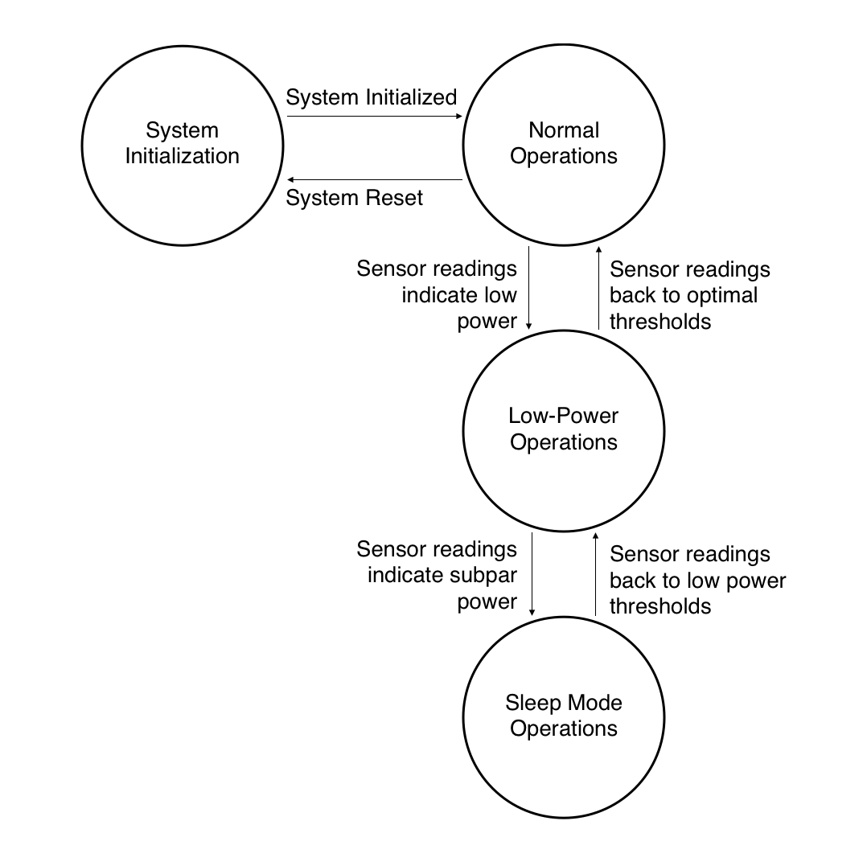

Figure 2: Finite State Machine for the Required States of the CDH Subsystem.

### Capability Requirements

System Initialization In order to successfully initialize, the On-Board Com- puter must follow a sequence of commands which are as specified as follows.

1. The system initialization sequence shall perform self-tests on the central processor to ensure that the processor and onboard software are fully functional and working as intended.

2. The system initialization sequence shall command all other subsystems on board to perform self-tests on their respective hardware subsystems to ensure that each hardware components are intact and the software controlling them are fully functional.

3. The system initialization sequence shall reboot the entire CDH subsystem if problems present itself during the self-tests for processor and all other hardware subsystems.

4. The system initialization sequence shall monitor all voltage and current sensors sta- tioned within the body of the CubeSat, and conclude the initialization stage when all readings are nominal.

System States and Flight Manager During the mission, the CubeSat will need to operate in different modes depending on the state of the incoming health-keeping data.

1. The CDH Subsystem shall transition into Normal Operations after the system initialization sequence conclude and all voltage and current sensor values are nominal, as defined by the CubeSat’s power budget.

2. The CDH Subsystem shall transition into Low Power Operations while in Normal Operations if voltage and current sensor values for the other subsystems are above the “Low Power” threshold values, as defined by the CubeSat’s power budget.

3. The CDH Subsystem shall transition into Sleep Mode while in Low Power Operations if the voltage and current sensor values continue to increase past the “Sleep Mode” threshold values, as defined by the CubeSat’s power budget.

4. The CDH Subsystem shall transition into Low Power Operations while in Sleep Mode if voltage and current sensor readings reduce down to the “Low Power” threshold value.

5. The CDH Subsystem shall transition into Normal Operations while in Low Power Operations if voltage and current sensor readings reduce down to the defined, nominal values.

6. The CDH Subsystem shall send the command to the Electrical Power Subsystem cut power to ADCS, PS, COM2 Subsystems while operating in Low Power mode.

7. The CDH Subsystem shall send the command to the Electrical Power Subsystem to cut power to ADCS, PS, COM1, COM2 Subsystems while operating in Sleep Mode, and also turn the OBC itself into low-power sleep mode.

8. The CDH Subsystem shall verify that all health monitoring data collected throughout the CubeSat are within predefined operating ranges.

9. The CDH Subsystem shall reboot the appropriate subsystem if the health monitoring data are not within range.

10. The CDH Subsystem shall shut down the appropriate subsystem if the health monitoring data are not within range and was previously rebooted.

11. The CDH Subsystem shall record every change of operation modes, as well as commands sent to the Electrical Power Subsystem to toggle the power to different subsystems.

Data Collection In order to monitor the health of the CubeSat and diagnose performance characteristics, the CDH Subsystem shall collect various sets of housekeeping data from the Battery, Electrical Power, and Thermal Subsystems.

1. The CDH Subsystem shall read from a set of 20 temperature sensors distributed throughout the CubeSat via the CAN bus every 100 millisecond, collecting data in the form of an 8-bits integer during Normal Operations.

2. The CDH Subsystem shall read from a set of 20 voltage sensors stationed within the ADCS, PS, COM1, COM2, via the CAN bus every 100 millisecond, collecting data in the form of an 8-bits integer during Normal Operations.

3. The CDH Subsystem shall read from a set of 20 current sensors stationed within the ADCS, PS, COM1, COM2, via the CAN bus every 100 millisecond, collecting data in the form of a 16-bits integer during Normal Operations.

4. The CDH Subsystem shall collect any error events from the Electrical Power System, via the CAN bus every 100 millisecond, collecting data encoded in the form of a 32-bit integer during Normal Operations.

5. The CDH Subsystem shall reduce the frequency of data collection from 100 millisecond in Normal Operations to 1000 milliseconds in Low-Power Operations.

6. The CDH Subsystem shall cease to collect health keeping data during Sleep Mode Operations.

Data Storage In order to keep a log of the performance characteristics of the CubeSat over time, the CDH Subsystem shall process and store various sets of housekeeping data from the Electrical Power, and Thermal Subsystems.

1. The CDH Subsystem shall find the minimum, maximum, and mean of a set of tem- perature data points collected over the CAN bus in a period of 1 second and place it in non-volatile storage during Normal Operations.

2. The CDH Subsystem shall find the minimum, maximum, and mean of a set of voltage data points collected over the CAN bus in a period of 1 second and place it in non- volatile storage during Normal Operations.

3. The CDH Subsystem shall find the minimum, maximum, and mean of a set of current data points collected over the CAN bus in a period of 1 second and place it in non- volatile storage during Normal Operations.

4. The CDH Subsystem shall log all error conditions from the EPS to non-volatile storage during Normal Operations.

5. The CDH Subsystem shall log the following telemetry data from the Attitude Determination & Control System collected over the CAN bus to non-volatile storage every 1 second:

• Wheel RPM averages (x3).

• Magnetorquers (x3).

• Magnetometers (x3).

• IMU (x3).

• Accelerometer (x3).

• Photodiode (x10).

• Estimator.

• GPS.

6. The system shall reduce the frequency of processing data form 1 second in Normal Operations to 10 seconds in Low-Power Operations.

7. The CDH Subsystem shall cease to process data while in Sleep Mode Operations.

8. The CDH Subsystem shall record the corresponding timestamp at which the data is averaged to storage.

9. The CDH Subsystem shall format the processed data along with the timestamps in a log format corresponding to different health monitoring data for each subsystems.

Data Uplink and Downlink In order to communicate to ground station, the Command & Data Handling Subsystem must interface with the Communication-1 Module, a low-frequency, uplink/downlink UHF/VHF link for downloading health keeping data, as well as receiving commands. The CDH will also interface with the Communication-2 Module, a high-frequency, downlink only K-band link for a technology demonstration.

1. The CDH Subsystem shall compress the necessary log data before the COM1/COM2 is allowed to stream the data to a ground station.

2. The CDH Subsystem shall interpret incoming commands from the COM1 Subsystem, and carry it through if valid.

3. The CDH Subsystem shall send a command to turn on COM2 on a predefined schedule, with possible updates coming from uplinked data through COM1.

4. The CDH Subsystem shall send a command to turn off COM2 if any volt/curr/temp data points is not within a predefined range, and wait for further commands received through COM1.

5. The CDH Subsystem shall authenticate all outgoing packets, as well verify all incoming packets to be coming from the UW ground station.

Fault Detection and Management In order to detect and manage faults occurring during the mission, we will be using a hardware watchdog. We will also not be using a software watchdog to reduce the complexity of the design.

Memory Integrity

1. The CDH Subsystem shall employ periodic memory integrity checking to make sure the memory content has not been corrupted by electromagnetic interference.

Hardware Watchdog

1. The CDH Subsystem shall employ a hardware watchdog to detect and correct system wide errors.

2. The hardware watchdog shall receive reports from the flight computer every 500 milliseconds.

3. The CDH Subsystem shall reset the flight computer into initialization mode if the flight computer fails to report to the hardware watchdog five times in a row.

4. If the CDH Subsystem reset too many times in a short timeframe, the system shall cut power to main computing processor, booting into initialization mode.

5. The CDH Subsystem shall employ an external hardware watchdog as the last line of defense against catastrophic errors.

6. The CDH Subsystem watchdog shall receive reports from the hardware watchdog every 5 seconds.

## ARCHITECTURE DESCRIPTION

Using the requirements defined in the previous section, we can define a list of tasks the main On-Board Computer should execute. Depending on the architecture used, the implementation of these tasks will greatly differ. In summary, if we were to go with a centralized architecture utilizing one microcontroller, a real-time operating system would be required to set the priority of each tasks and for context switching to achieve multitasking. If we were to go with a decentralized architecture, each microcontroller would be in charge of implementing a different tasks. We would just have to focus more efforts into developing a communication and synchronization scheme between each microcontrollers.

To repeat, these are the necessary tasks needed for the Command & Data Handling subsystem as dictated by the functional subsystem requirements:

• System Initialization.

• System States & Flight Manager.

• Health-Keeping Data Collection of the CubeSat.

• Health-Keeping Data Storage of the CubeSat.

• Preparation for Data Uplink and Downlink.

• Fault Detection and Management

## BUS TRADE STUDY

First, in order to motivate the options for the possible architectures, we need to first investigate the method for communication between microcontrollers for a decentralized scheme, as well as incoming data from all subsystems over the entire CubeSat. The two possible choices that we are considering are the I2C bus, as well as the CAN bus.

I2C is a single-master (but can also be configured into a multi-master mode), multi-slave, single-ended, serial computer bus. The physical bus is composed of just two wires: a data line and a clock line. The devices on the bus can be a master or a slave, with the master being in charge of driving the clock line to synchronize all units, and the slaves responsible for responding to the master. There are usually only one master, but can be multiple slaves. Each device on the bus can have a unique address for identification purposes, and the slave cannot transmit data unless it has been addressed by the master.

More About I2C: http://www.ti.com/lit/an/slva704/slva704.pdf

CAN is a multi-master, message-based, serial vehicle bus standard, most commonly used in the automotive industry for connecting Electronic Control Units (ECUs) called nodes. A node can be as simple as an I/O device or an embedded computer. Regardless, all nodes must compose of a computing unit, a CAN controller, and a transceiver. The computing unit is in charge of interpreting the received messages, and deciding what to transmit from any possible sensors, actuators, etc. connected to the host. The CAN controller is responsible for transmitting a message to the bus through a bit stream, as well as storing a bit-stream message until the entire thing is available. The transceiver is responsible for converting the data stream from the CAN controller to the CAN bus level for transmitting, as well as converting back from CAN bus level to the CAN stream level for receiving.

More About CAN: http://www.ti.com/lit/an/sloa101a/sloa101a.pdf

COMPARISON I2C uses single-ended signaling, while CAN uses differential signaling. This means that CAN is much more reliable when noise is present within the system. Furthermore, I2C requires additional error checking, while CAN has multiple layers of error checking already built-in. One of the last point we are considering is the fact that I2C requires a single master (it can be configured into a multi-master mode, but to do would be add additional complexity into the design), while CAN doesn’t. This means that using I2C would essentially force us to go with a centralized design, requiring all data to pass through the CDH subsystem. While this is fine for the first mission, in order to scale up in size for future missions, I2C would no longer be a practical choice. If we were to choose the CAN bus, our choice of architecture would be must more flexible, and communication between microcontrollers would be far easier to develop and maintain.

One drawback to using the CAN protocol is that both the MSP432 and the MSP430FR does not come with innate CAN support, so we would have to purchase a CAN controller and a transceiver and integrate it with both types of microcontrollers. This extra overhead in hardware integration can be justified when compared to the development work necessary in implementing error-checking for I2C.

In summarizing the justifications laid out in the previous sections, scores have been assigned to the performances of the I2C and the CAN with respect to the following categories from a scale of 1 to 5. The final recommendation relies on the totaled scores of both bus protocol, with each category weighed equally.

Table 1: Trade study for the final bus (1 = worst, 5 = best).

|  |  |  |
| --- | --- | --- |
| **Category** | **CAN Bus** | **I2C Bus** |
| Scalability | 5 | 1 |
| Noise Protection | 4 | 1 |
| Error Checking | 4 | 1 |
| Implementation Overhead | 1 | 4 |
| Development | 3 | 1 |
| **Total** | **17** | **8** |

With respect to the final tally of the scores for each categories, a CAN bus working with a centralized or a decentralized architecture looks to be the preferred approach, since we are not locked into a single-master mode like with I2C.

## TRADE STUDY FOR EACH ARCHITECTURE

With the decision of a CAN bus, we can go ahead with either the decentralized approach or a centralized approach. Because of the requirement of multiple tasks needing to be executed all at once over the mission lifetime (see section 3), a centralized architecture would require the use of a real-time operating system to efficiently switch tasks, as well as setting the priority to each tasks. If we were to choose a decentralized approach, the CAN bus allows us to assign priority to different devices each executing a single task at any given time, achieving essentially the same feature as implemented by a RTOS.

Furthermore, because the MSP430FR does not have enough memory/possess the computing power to execute all tasks needed, the centralized architecture would fully depend on an MSP432 to do most of the work. However, for the decentralized architecture, because each tasks can be implemented on one single microcontroller, we can take advantage of the radiation tolerant FRAM provided by the MSP430FR. Therefore, each system architecture scheme really relies on the performance of its microcontroller: MSP432 for centralized, and MSP430 for decentralized.

In the following subsections, we will be going over the advantages and disadvantages of each scheme with respect to the following characteristics for its microcontroller:

1. Power Consumption

2. Code Corruption

3. Reliability

4. Complexity

5. Development

6. Overhead

At the end of this section, we will conduct a trade study of the two architectures under consideration, and propose a hybrid solution for a pseudo-centralized approach.

## POWER CONSUMPTION

The MSP432 is a special low-powered microcontroller, and only uses approximately 3 mA at 3.0V with a 48 MHz clock (Figure 3).

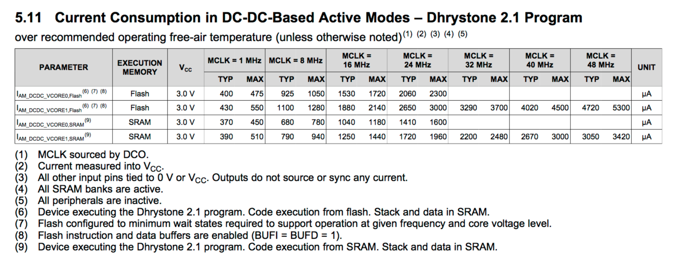

Figure 3: From http://www.ti.com/lit/ds/symlink/msp432p401r. Details the power con- sumption of the MSP432 at different clocking rates.

In comparison, the MSP430FR is also very energy efficient, consuming 2.2 mA at 3.0V with a 24 MHz clock (with a 66% cache-hit ratio) (Figure 4).  
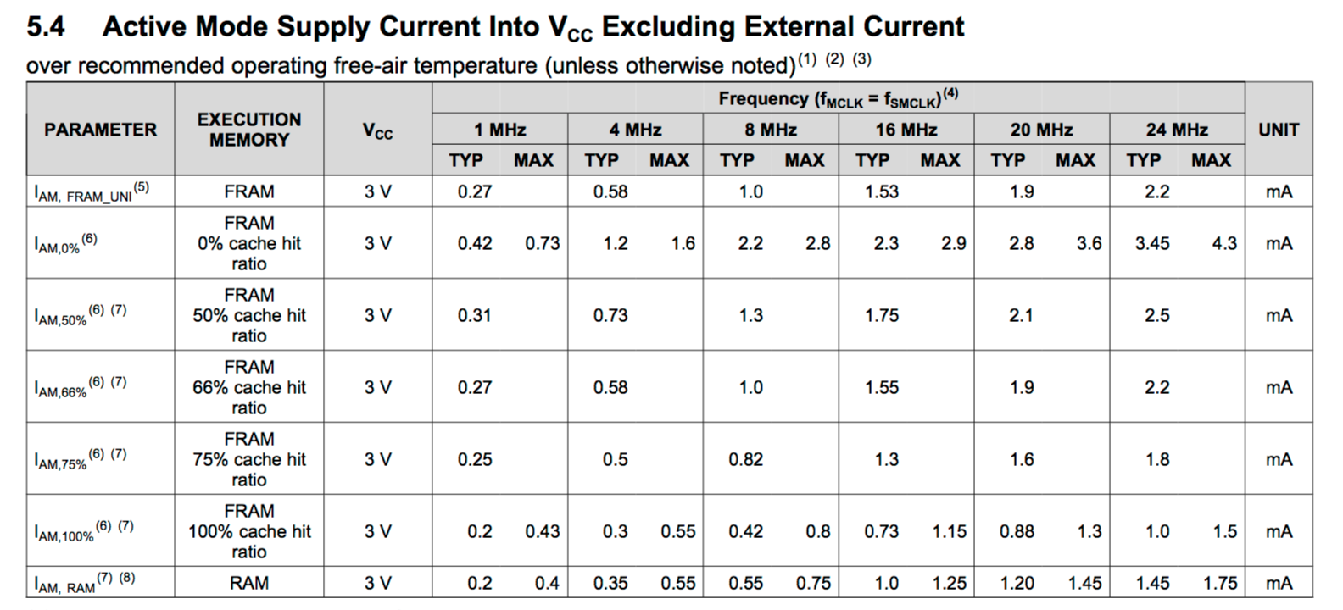

Figure 4: From http://www.ti.com/lit/ds/symlink/msp430fr5739. Details the power con- sumption of the MSP430FR at different clocking rates.

For a proposed decentralized design, we would require at least four MSP430FRs to accomplish all the necessary tasks. Given the design, if more than two microcontrollers are active at any given time, the power consumption would be worst for much less absolute performance due to the slower clock rate, the reduced address space, as well as the optimized efficiency coming from the ARM architecture. This can be shown in benchmarks: the MSP430FR can run 1.1 CoreMark/MHz, while MSP432 can run at 3.40 CoreMark/MHz. Factoring in the difference in clock speed, the MSP432 is 10x powerful while consuming 1.5x as much power.

Furthermore, the CDH Subsystem requires computing power for quite many tasks, such as computing daily download and beacon data, and message authentication, so the power consumption from the MSP432 may be that of a necessary one.

## CODE CORRUPTION

The MSP430FR uses the Ferroelectric RAM (FRAM) universal memory, which is very radiation resistant and is nonmagnetic, and has built-in ECC (Error-Correcting Code). From TI:

“Volatile memories, DRAM and SRAM, use a capacitor to store charge or a simple latch to store state. These cells can be easily upset by alpha particles, cosmic rays, heavy ions, gamma, x-rays, etc. which cause bits to ip to an opposite state. This is called a soft error, since a subsequent write will be retained. The rate at which this occurs is called the Soft Error Rate (SER) of the device. Because the FRAM cell stores the state as a PZT lm polarization, an alpha hit is very unlikely to cause the polarization to change a given cell’s state and the FRAM terrestrial SER is not even measurable. This ‘radiation resistant’ characteristic of FRAM makes it attractive for use in several emerging medical applications.”

As such, code corruption due to memory corruption is much less of a concern on this platform.

The MSP432 uses flash memory for program storage, and SRAM for memory. Because of this, the microcontroller is much more prone to radiation and requires extensive measures to be taken to protect against corruptions to the bootloader stored on-chip, as well as to the operating systems and executables. One possible method of protection is to store the bootloader off-chip, along with multiple copies of the operating systems on FRAM off-chip so that the microcontroller can reprogram the processor with a gold copy in case of corruptions.

## 

## RELIABILITY

A decentralized architecture distribute points of failure across the system, making it more difficult to have a complete system failure due to single failures in any MSP430FRs used. Failures will most likely lead to loss of certain functionalities, without jeopardizing the mission. The MSP430FR also employs ECC, as well as a higher temperature range, making it much more reliable, operationally.

However, if we were to introduce single points of failure in the architecture, a decentralized architecture would lose out any benefits in reliability, and because of the increased complexity in the system, may in fact be less reliable than a centralized architecture.

## COMPLEXITY

A decentralized architecture is inherently harder to engineer and test, due to the increased complexity in communication and coordination. Mutual exclusion (meaning two processors having to share any resources at any time during the mission) is harder to implement on a decentralized architecture. Traditional mutual exclusion techniques (mutex, semaphores) are based on atomic access to shared memory, which is not available on a multi-chip design. This can be solved by having a processor that is in charge of maintaining locks, which would be a single point of failure in the decentralized system (see section above), or just design the system so that no two processors would ever need the same resources at the same time at any given moment during operations.

## 

## DEVELOPMENT

A decentralized architecture does not make it easier or harder to parallelize work. With the centralized approach, on a MSP432 running FreeRTOS, each task is relatively isolated and thus can be developed in parallel. Each task will also have its own source code file, thus not requiring expensive conflict merges.

With the decentralized approach, we simply replace tasks with individual processors. However, this doesn’t make tasks completely isolated from each other - they still have to share certain information. Furthermore, in this scheme, information sharing will be more difficult to implement, having to rely on messages passing over physical wires instead of shared memory, increasing the complexity of the communication scheme.

## OVERHEAD

A centralized architecture running an RTOS involves the overhead of context switching to handle the execution of multiple tasks. However, this overhead is usually very low for modern microcontrollers. A Cortex M3 chip at 40 MHz incurs 13.8 μsec latency on every task switch [http://sci-hub.cc/10.1109/embeddedsys.2014.6953051].

While this overhead is not included in the decentralized architecture, we have to worry instead about the passage of information between microcontrollers, which imparts an additional overhead of exchanging data over physical wires and encoding/decoding this data on both ends of the transmission. However, since we are using the CAN bus, we won’t have to focus on microcontrollers needing to exchanging information directly between each other. They can just read the necessary information off of the CAN bus whenever needed.

## 

In summarizing the justifications laid out in the previous sections, scores have been assigned to the performances of the centralized scheme using a MSP432 and the decentralized scheme using a MSP430FR with respect to the following categories from a scale of 1 to 5. The final recommendation relies on the totaled scores of both microcontrollers. However, as a student team, we want to place a special weight on the code corruption, reliability, and complexity of our architecture, since those three sections are crucial to a working CDH subsystem. As such, the scores for those three sections will be weighed twice as much in the final tally.

Table 2: Trade study for the final OBC’s architecture (1 = worst, 5 = best).

|  |  |  |
| --- | --- | --- |
| **Category** | **Centralized** | **Decentralized** |
| Power Consumption | 5 | 3 |
| Code Corruption | 2 (x2) | 5 (x2) |
| Reliability | 3 (x2) | 4 (x2) |
| Complexity | 4 (x2) | 3 (x2) |
| Development | 4 | 2 |
| Overhead | 2 | 2 |
| **Total** | **29** | **32** |

With respect to the final tally of the scores for each categories, a decentralized design using four MSP432FRs looks to be the preferred approach.

## ARCHITECTURE PROPOSAL

From the previous sections, we have concluded that a decentralized approach using four MSP432FRs is the preferred architectural design for the Command & Data Handling Subsystem. Below is a proposed block diagram for such an architecture.

The architecture really depends on the usage of the CAN bus, allowing data to constantly pass through from all subsystems and microcontrollers, only to be picked up by the correct microcontroller if it cares about the incoming messages. The types of messages that will be seen over the CAN bus are:

1. Normal telemetry data (this includes information about if subsystems were rebooted/shut-

down/error conditions).

2. Raw telemetry data.

3. Compressed and authenticated telemetry data for downlinking.

4. Beacon data.

5. Ground station commands.

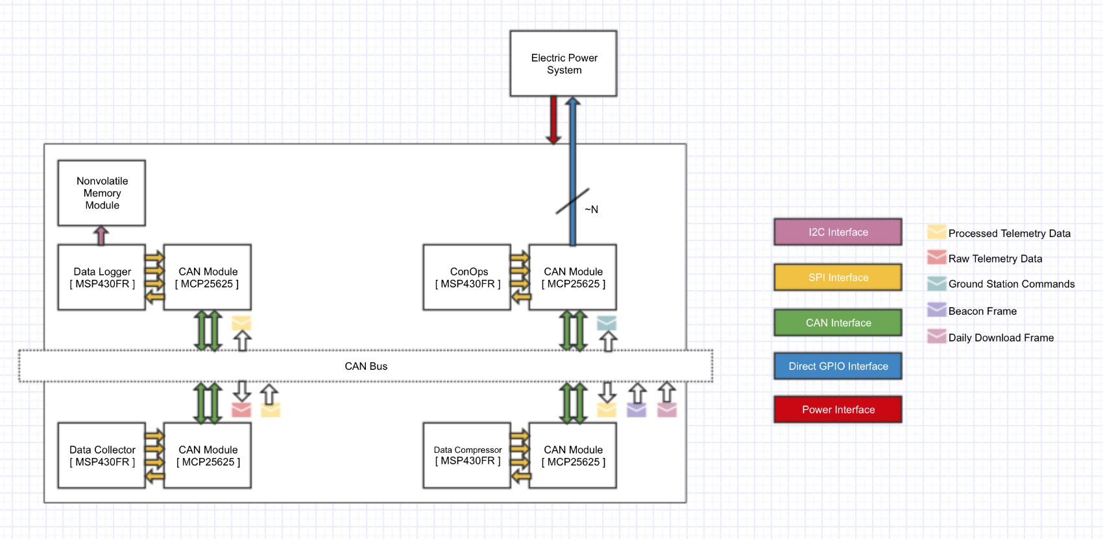

Figure 5: Proposed block diagram for a decentralized architecture.

# COMMUNICATION SYSTEMS (Slides 42-55)

## Link budgets

Shown below are three link budgets for both COMM1 and COMM2.

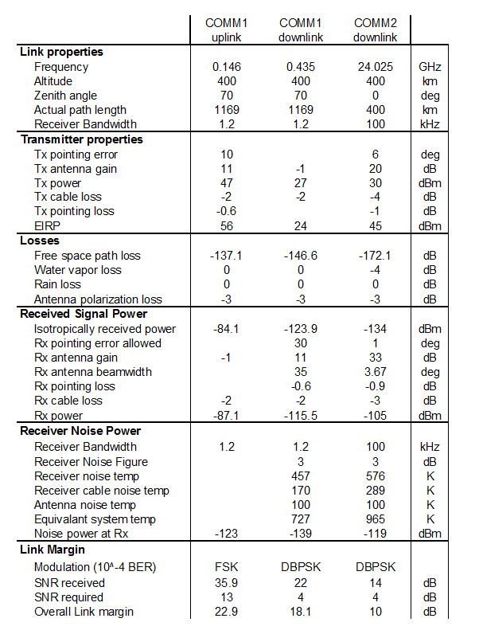

For COMM2, generating 24GHz is done by using a UW developed upconverter and power amplifier PCB termed the RF Front End. This is shown below:

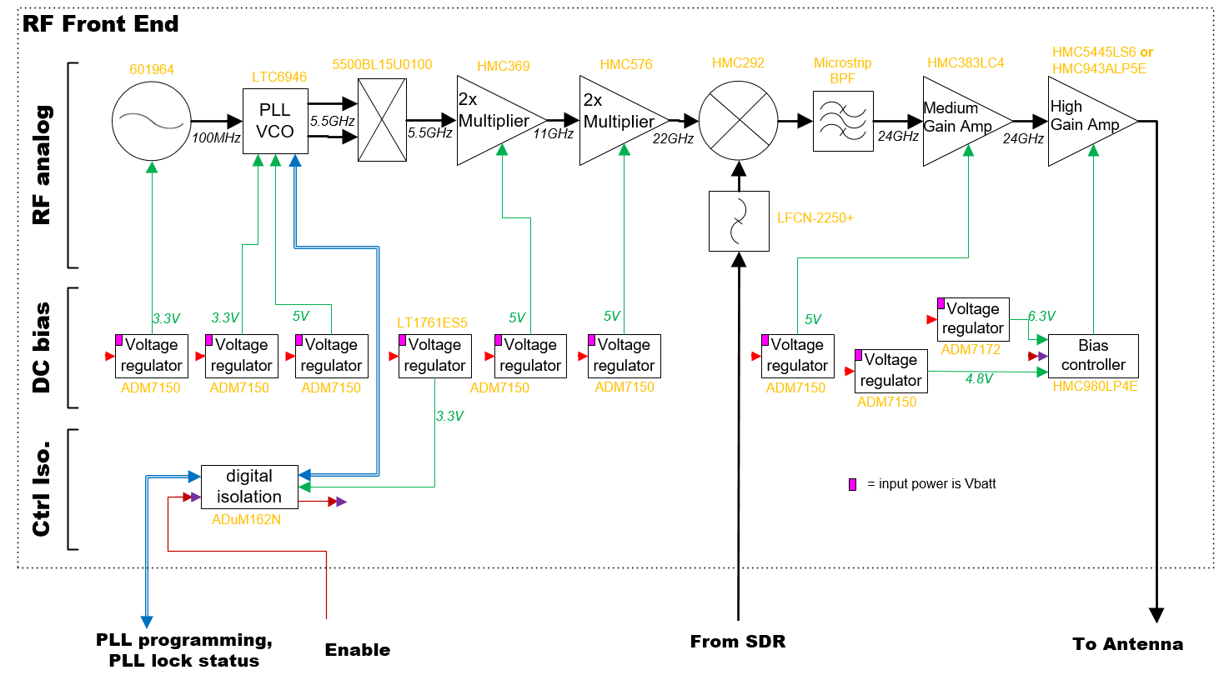

All sections have been prototyped and implemented except for the two last RF stages. The PCB material is Rogers 4003.

The ground station to interface with COMM1 and COMM2 are also being developed by UW. A single antenna rotator will house the UHF, VHF, and K-band antenna. UHF and VHF RF front end equipment, such as a power amplifier, low noise amplifier, and filters will be purchased, while the K-band RF front end will be developed in-house. SDR’s will be relied on heavily for baseband processing.

* Two SDRs are used in COMM1: one dedicated for FSK VHF uplink and another for DBPSK UHF downlink.
* Two SDRs are used in COMM2: one is dedicated to frequency acquisition, while the other demodulates the signal. When transmitting, COMM2 will switch between sending a pure sine wave down at the carrier frequency, and then sending data packets. A packet consists of:
  + Barker sequence + Call Sign + “Go Dawgs, University of Washington” + “packet[xxxxx]”

The ground station software interface will provide an autonomous tracking and communication with the CubeSat. The software architecture for the ground station is:

